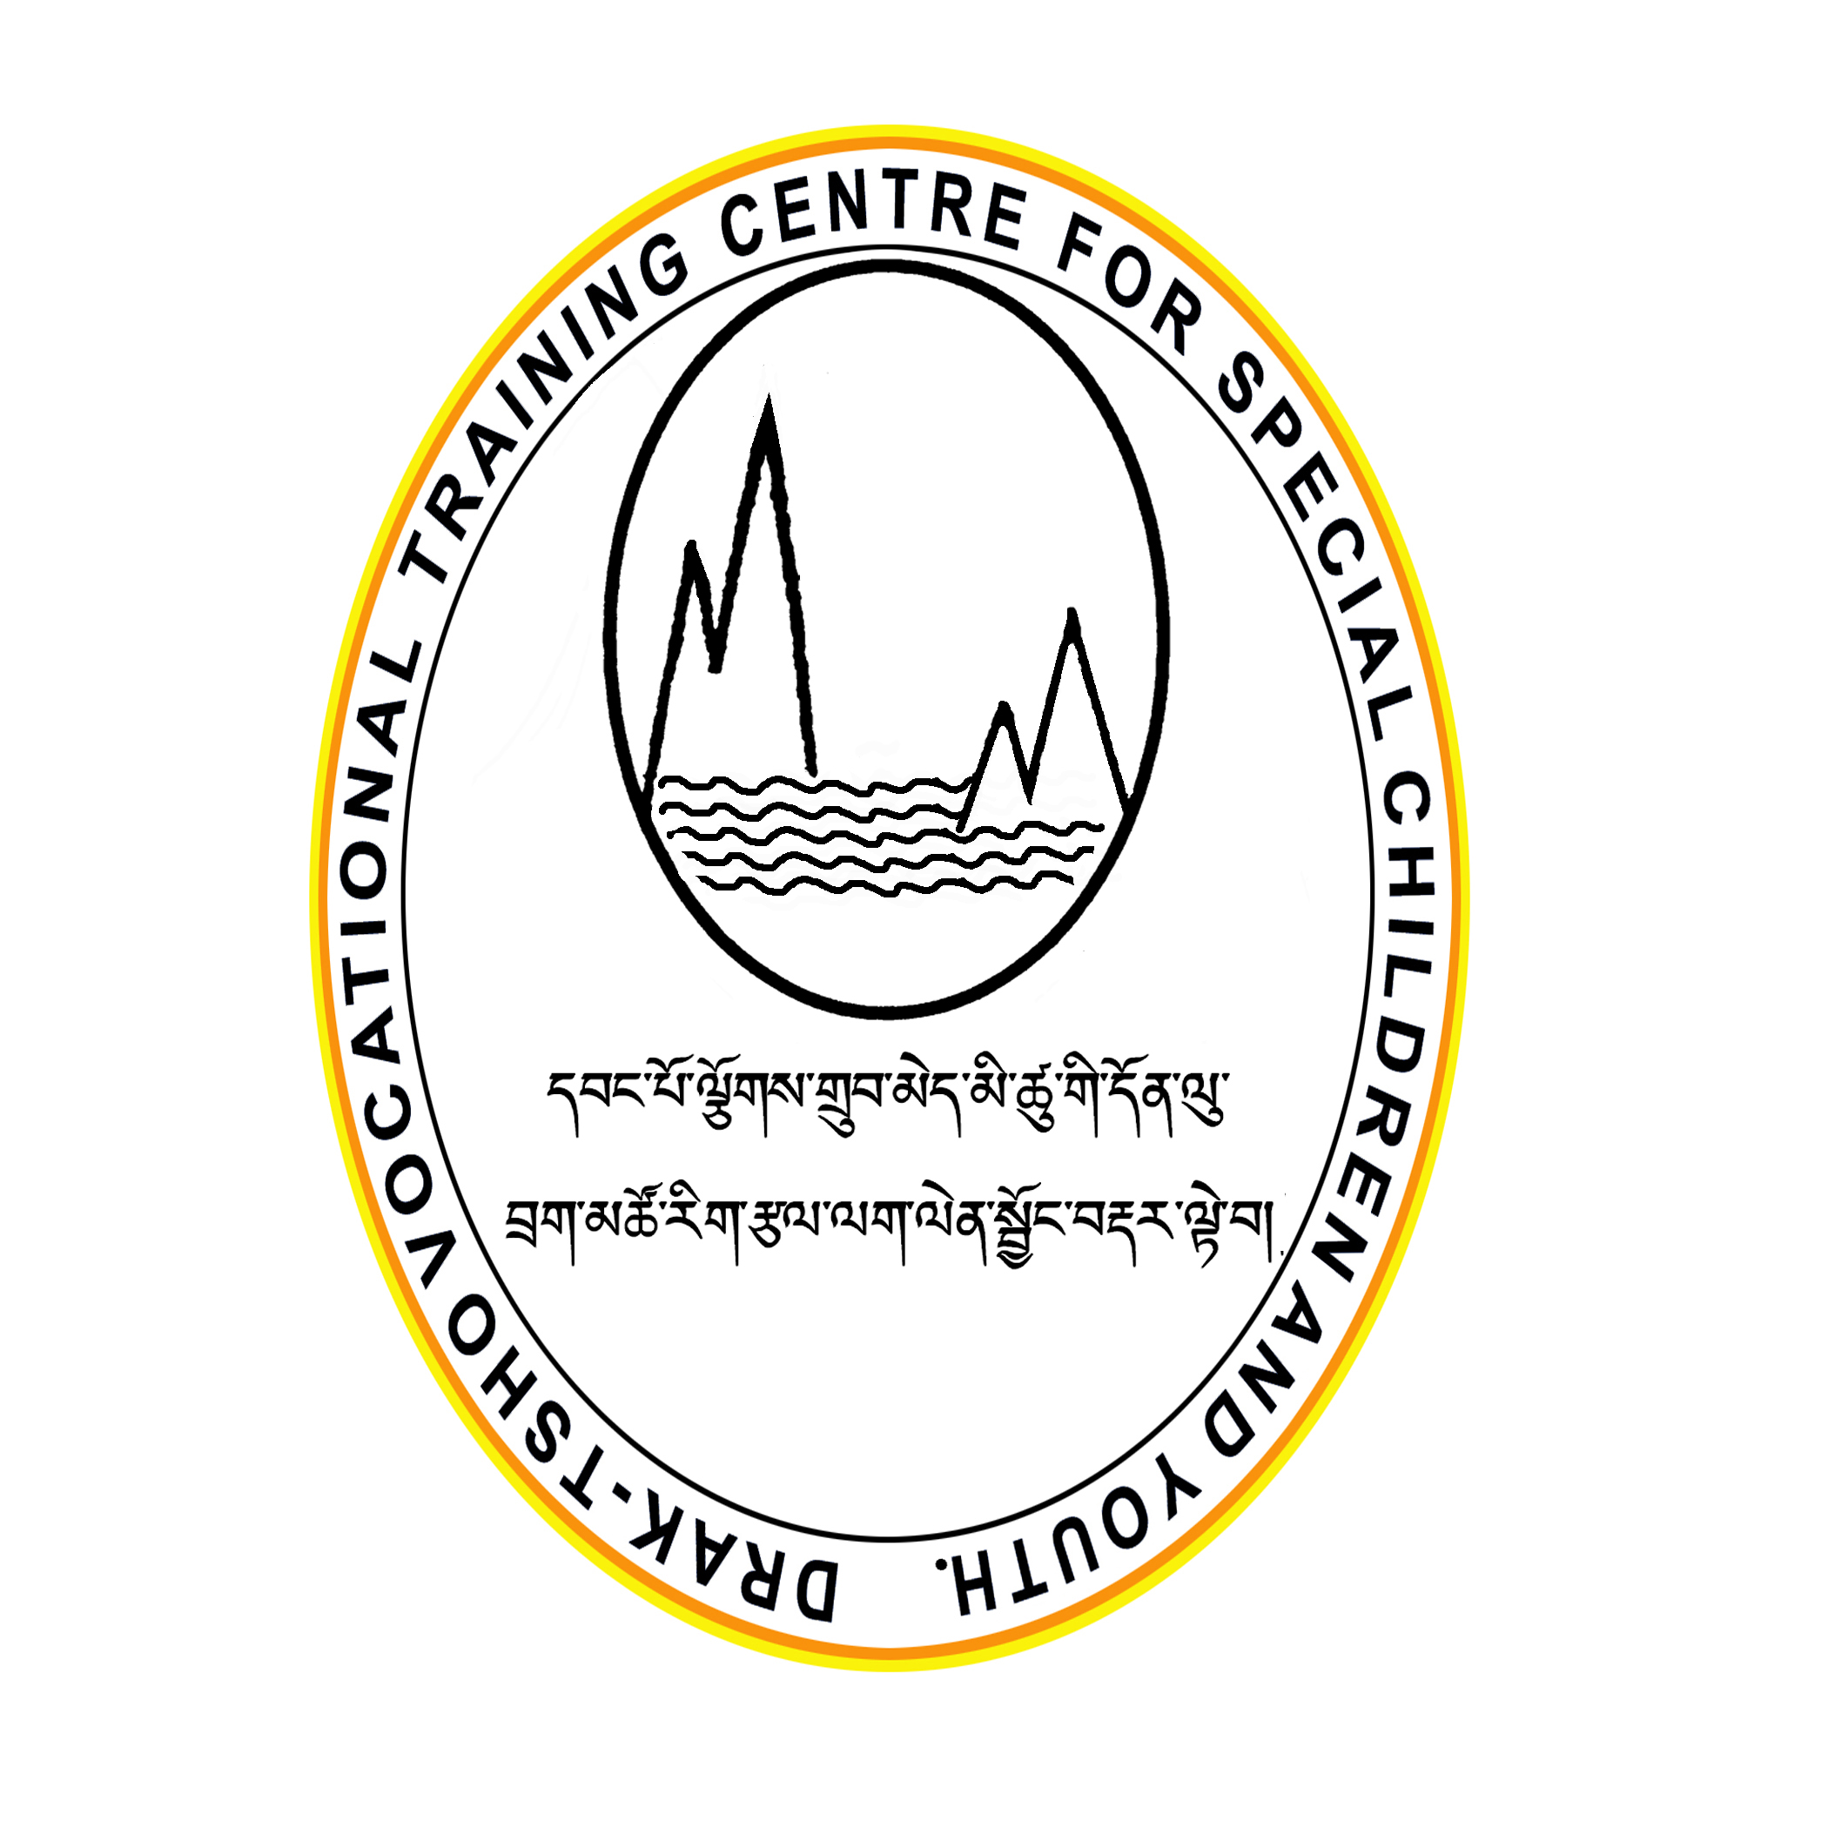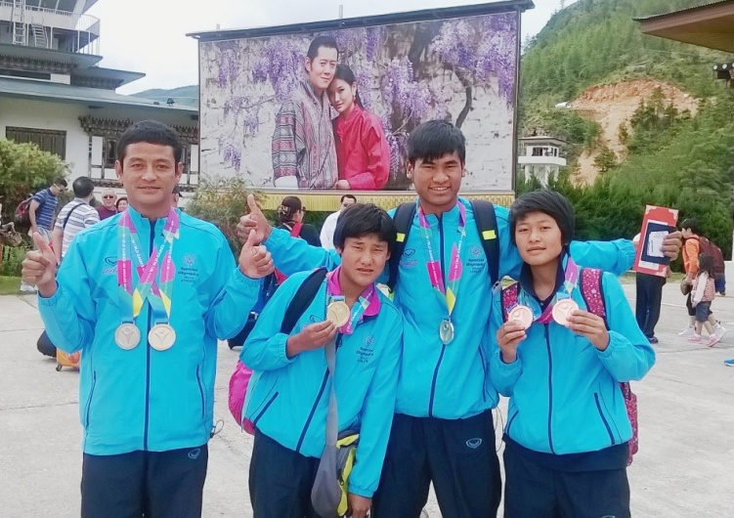
Annual Report 2015
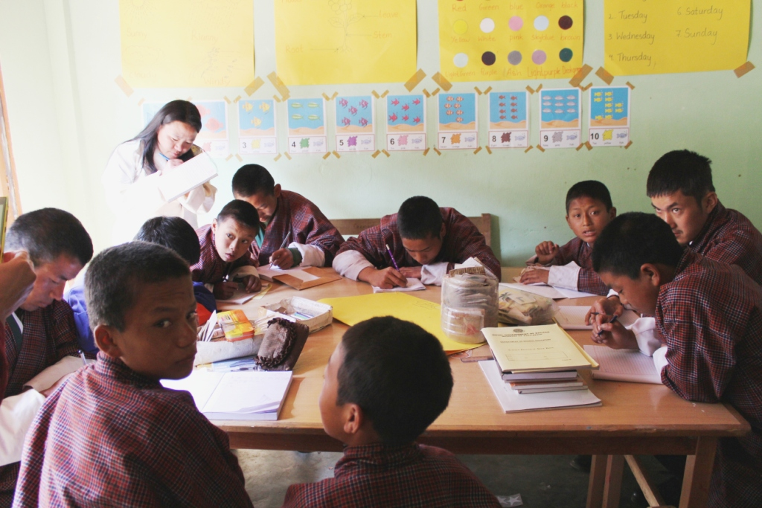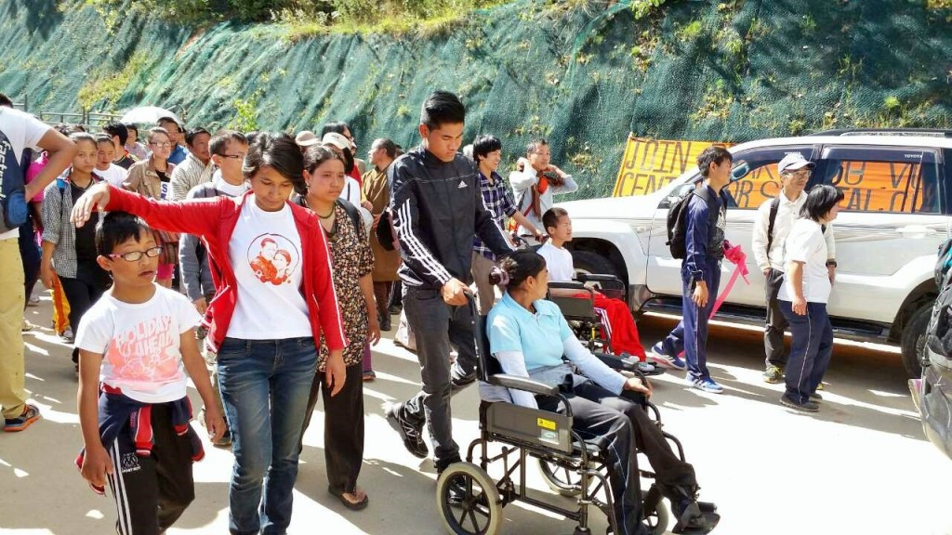
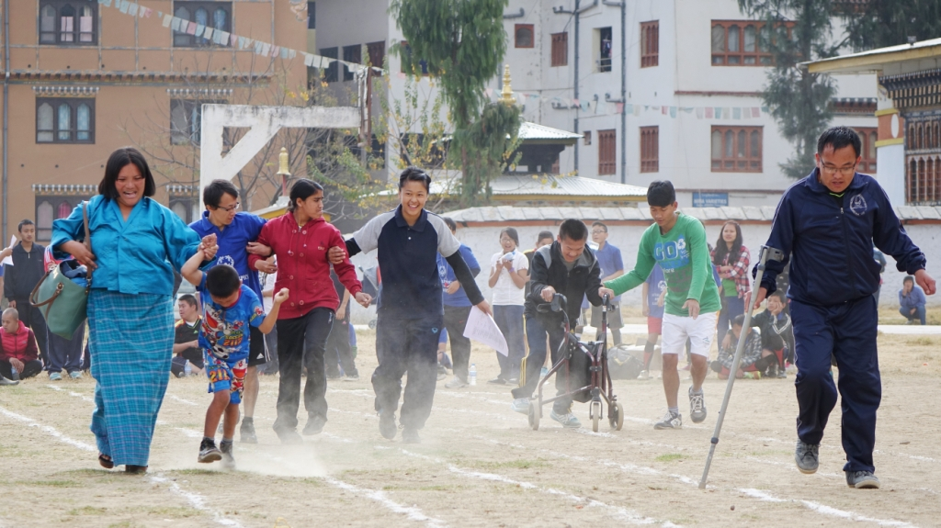
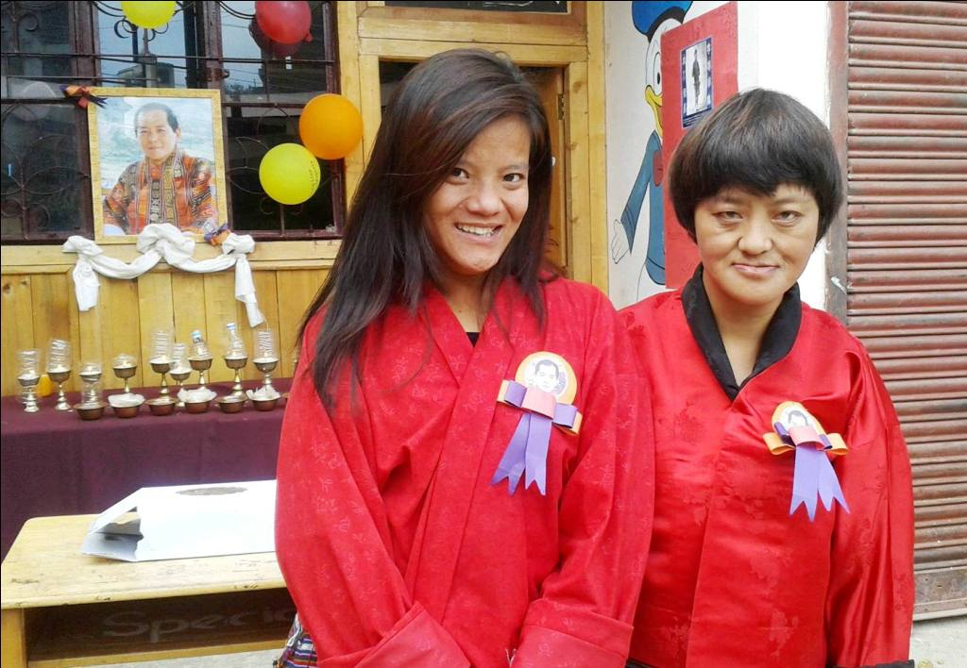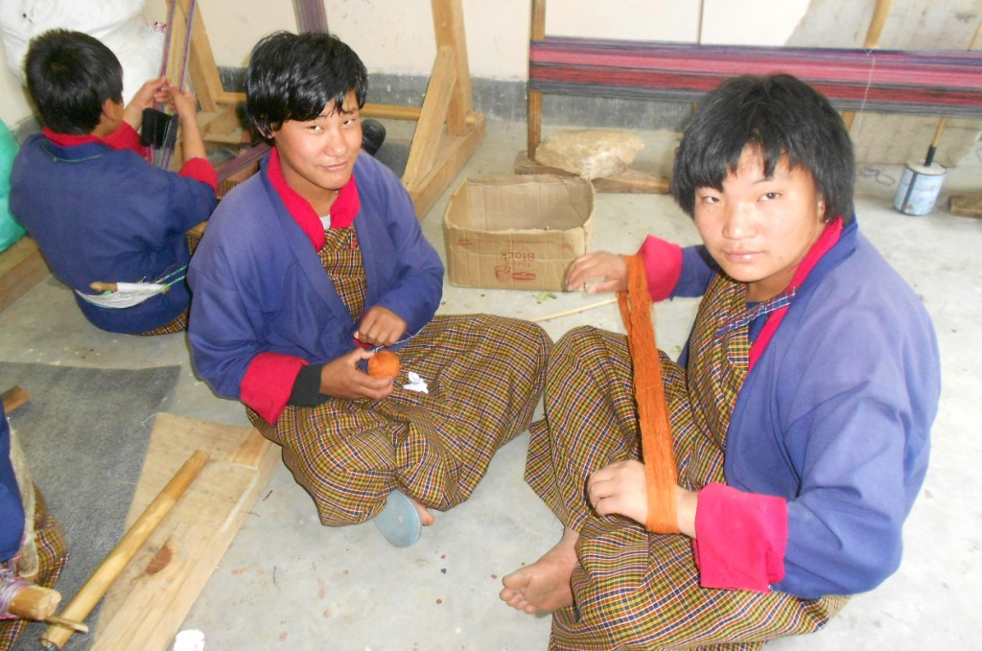
Forward:
It is a great opportunity and privilege for me to serve the children and youth with disabilities of our country. It is extremely challenging to keep going when there are so many needs and demands that need to be fulfilled, no matter how much we try to put in our work seem inadequate. However, when one look at their smiling faces, hear their laughter and see the results of their education a divine energy and eagerness to go the extra mile fills in.
The centres made significant progress and successfully carried on with its ongoing activities. We had more students coming from all over Thimphu and Eastern districts. The construction of Draktsho East facilities supported by JICA, New Delhi India marked the beginning of an independent centre which would cater a large number of services to over 200 students.
The budget is essential to organize the work of the centre and to prepare for the future. The budget has always been the biggest challenge for Draktsho. Despite low budget we managed to move on with all our activities and initiated additional programs for our students. For this we would like to extent our appreciation and thanks to all our pledged donors, partners like UNICEF, HEVETAS, UNDP, India House for their support. We would also like to thank our stakeholders, individual donors, volunteers and friends who have made 2015 a successful year for Draktsho.
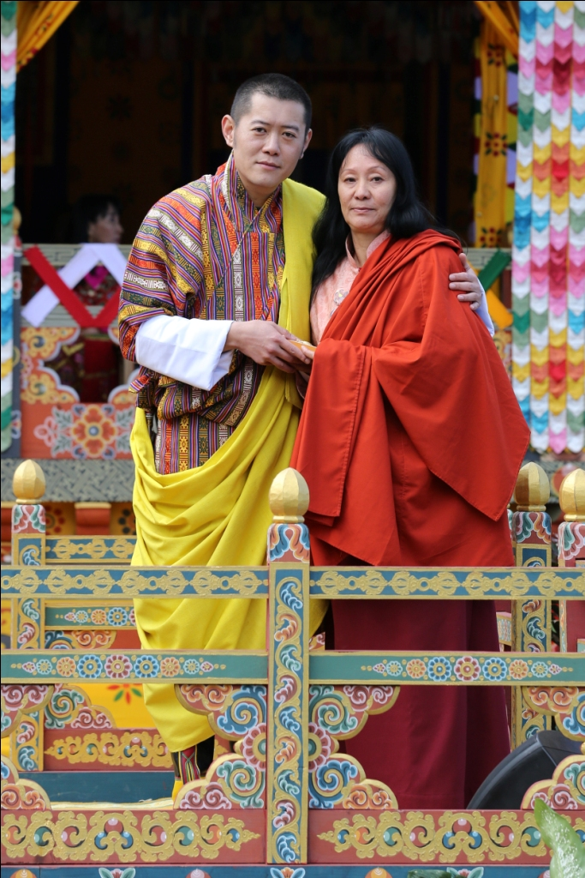

Rigzin Padma Tsogyal
Founder/Executive Director
Draktsho Vocational Training Centre for Special Children and Youth

Content:
Pg. 4-5 Introduction
- Vision
- Mission
- Goals
- Objectives
- Programmes- Vocational and Co-curricular programs

Pg. 6-13 Programs
- Outreach program
- Special Education Training
- 2nd April- celebration of World Autism Day
- Completion of new Draktsho East Centre
- 2nd May- Teachers Day Celebration
- Special Olympics World Summer Games
- Awareness Walk
- Celebrating Foundation Day
- Disability Registration Project
- His Majesty 4th Druk Gyalpo's 60th Birth Anniversary Celebration
- Visit of Ambassador of Federal Republic of Germany
- Celebration of International Day of Persons with Disabilities

Introduction
On 26th Novermber,2010, Draktsho Vocational Training Centre for Special Children and Youth was registered as a Civil Society Organization, a Public Benefit Organization under the Civil Society Organization Act of Bhutan 2007. Draktsho caters educational, vocational, life and other social skills to children and youth with all types of disabilities in Bhutan.
Although Draktsho provides various personal development skills, its main focus is to equip the students with vocational skills to enhance their opportunities for gainful employment. It also aims to build their self-esteem and self-reliance, thereby making them more independent, confident and contributing members of the society. Draktsho encompasses opportunities that allow them to grow in their aptitude, determination, goals and dreams. One of the greatest challenges for the Draktsho is to erase the deeply embedded stigma that people with disabilities are incapable of independence.

Vision

“Persons with Disabilities in Bhutan will actively and equitably participate in socio-economic development of the country and live a fulfilling life”

Mission
“To ensure young Persons with Disabilities in Bhutan have quality opportunities for developing skills for life and vocation, and for becoming self-reliant, make a living and lead a contended life overcoming barriers created by gender or other differences”

Goals
- Draktsho will be a centre of excellence in Bhutan providing state of the art training and supportive services for vocational training, employment and quality living for persons with disabilities.
- Draktsho will work with all different kinds of special needs children and youth, with special focus on children/ youth with intellectual impairments.
- Draktsho will work with children/youth and adults with disabilities and their families.
- Draktsho will be proactive in promoting equal work opportunities for persons with disabilities keeping in view the employment scenario for youth in Bhutan.
- Draktsho will be a model activity-based program, generating concepts and methods for promoting employment for persons with disabilities that can be adopted by similar services in urban and rural areas of Bhutan.
- Draktsho will adopt approaches and methods that foster and reflect inclusion.
- Draktsho will develop as a facilitator and a technical resource base for promoting employment of persons with disabilities.
Objectives
- To provide training in life skills including basic literacy and numeracy to children and youth with various types of disabilities for enabling them to cope with their daily life needs in present and future.
- To equip students with disabilities with vocational and work skills as preparation for sheltered, open or self-employment.
- To facilitate the students with disabilities secure work with dignity.
- To initiate dialogue, build collaborations and networks with different stakeholders (government, industry, institutions etc) for actively promoting equal opportunities for people with special needs.
- To organize parent support and community outreach program for raising awareness and generating support for inclusion of persons with special needs.
- To conduct training, research and documentation for building human resources, supporting innovative actions and generating resource material and data for supporting quality services and advocacy.
Programme
Vocational and Co-curricular programs:
The Vocational training and other co-curricular activities given below are some of the training programs offered at the centre. The vocational training is traditional based and it suits the capacities of the students. New skills depending on the requirement of the students would be introduced in the future.
Main Vocational Courses offered:
- Tailoring,
- Traditional art and painting
- Embroidery
- Weaving
- Basket weaving (cane and plastic)
- Souvenir carpentry (wood carving)
- Souvenir making (cards, bookmarks and dolls)
- T-Shirt and Mug Printing
- Envelope Making
Life skills offered:
- Personal management skills
- Sign language (communication skills)
- Social Behaviour, domestic behaviour
- Work related or Functional Academic
- Safety skills
- Occupational skill
Co-curricular Activities:
- Social skills (dancing, singing, acting and cultural disciplinary programs)
- Physical fitness programs: Special Olympics type of sports are being promoted by Draktsho, the organization is often used as the base for promoting sports for athletes with disabilities as Draktsho has maximum number of children and youth with various types of disabilities. Draktsho’s athletes two boys and two girls have won a gold medal in mix relay race in the Special Olympic, World Summer Games, held in Athens, Greece 2011. Again 4 athletes of Draktsho participated at the Special Olympics, World Summer Games in Los Angeles in 2015. The athletes brought back home 6 medals (3 gold, 1 silver and 2 bronze).
- Horticulture - Basic flower and vegetable gardening skills are taught to students at Draktsho East Centre
Programs:
Out Reach Program: Participation at the Trashiyangste Bazaguru Dungdrup (Guru Rinpoche mantra recitation)
Bazaguru (Mantra of Guru Rimpoche) Dungdrup recitation is conducted every year corresponding to the 1st month of the Bhutanese Calendar by a group of Trashi Yangtse people for the well-being of the sentient beings in this world and to offer prayers for the long life of the King. The billion/million recitation of the mantra was presided over by His holiness Khamtruel Rinpoche. Draktsho participated in the recitation ceremony for three days from 7th to 9th March, 2015 to support solidarity to dharma activities, to get a sense of fulfilment and meaning of life. Besides this student of Draktsho East centre performed cultural programs to create awareness among general population on disability issues and to reduce the social stigma and discrimination. This is the second time Draktsho east participated in such a programme.
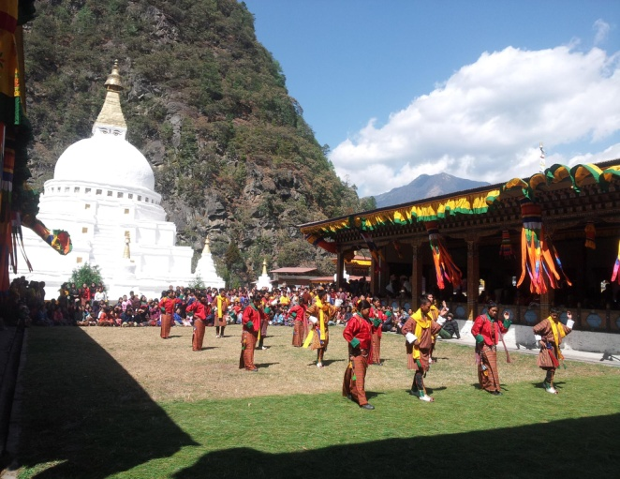
Special Education Training:
13 teachers of Draktsho Thimphu centre underwent a two weeks training on Special Education. A professional consultant from India trained the teachers on how to develop: an individualized education program, taking case history, discussion on assessment tools, diagnosis using the Autism Rating Scale and task analysis. The students and parents were also involved during the assessment and case studies. This project activity was funded by the Australian High Commission in New Delhi.

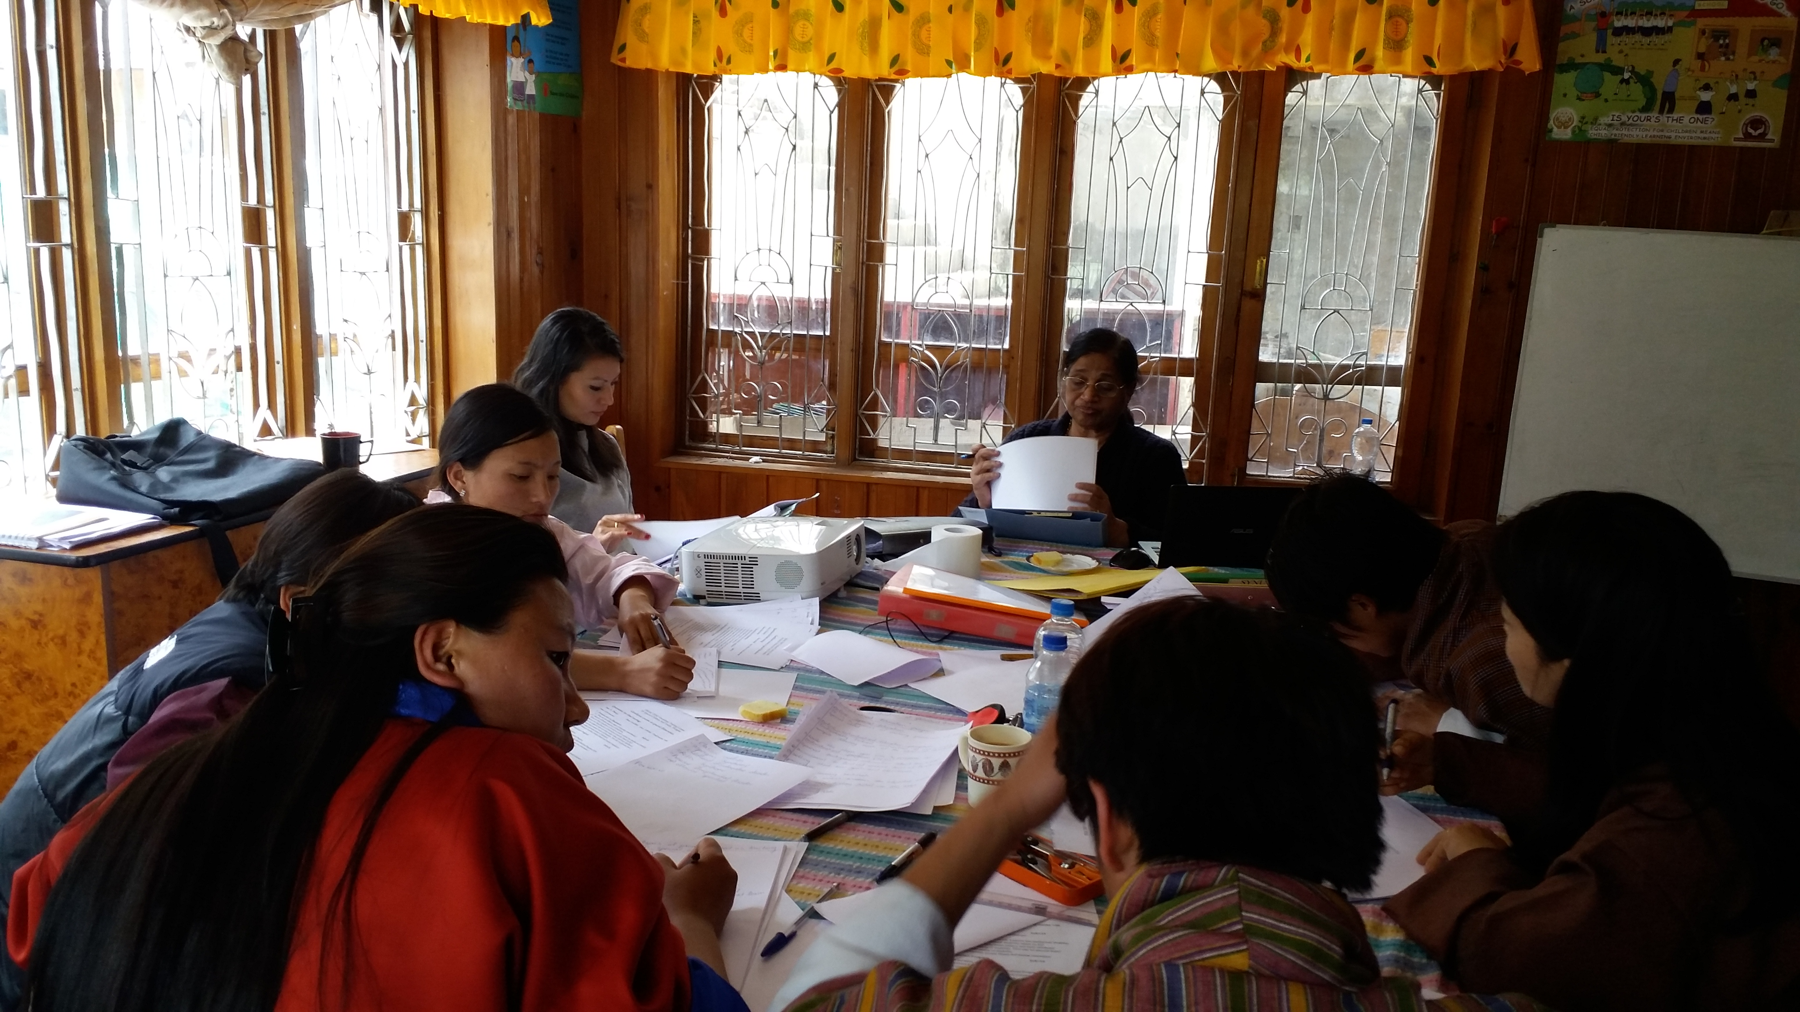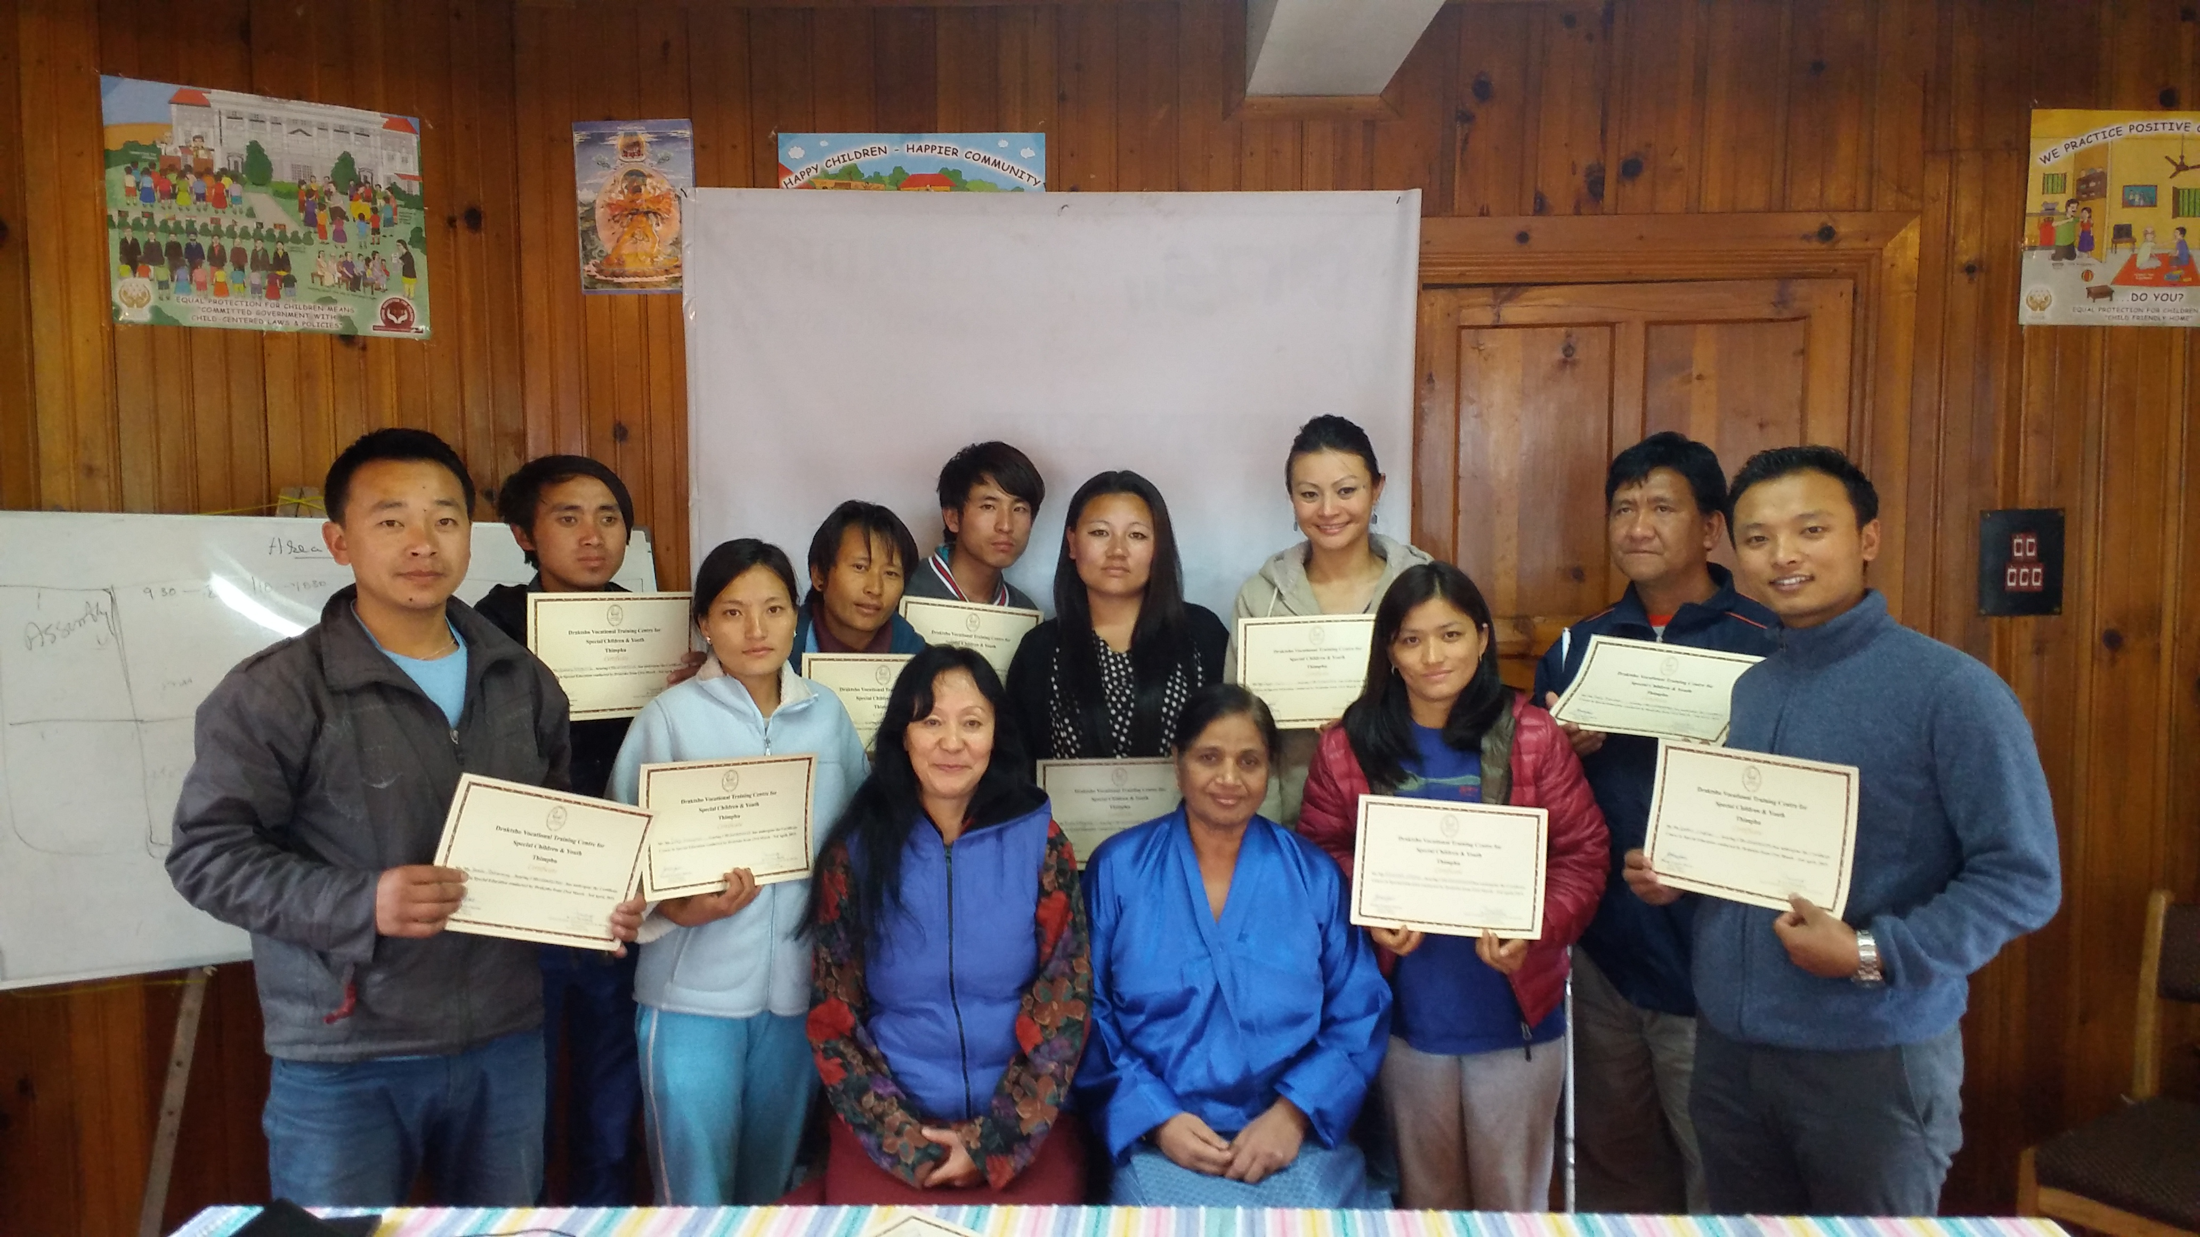
2nd April : Celebration of World Autism Day
On 2nd April Draktsho celebrated the World Autism Awareness Day. Every year around the globe organizations celebrate the day with unique awareness and fund-raising events to promote acceptance and social inclusion. Students, teachers, volunteers and parents of Draktsho celebrated this special by raising awareness on Autism through various cultural programs that showcased the abilities of children and youth with disabilities.
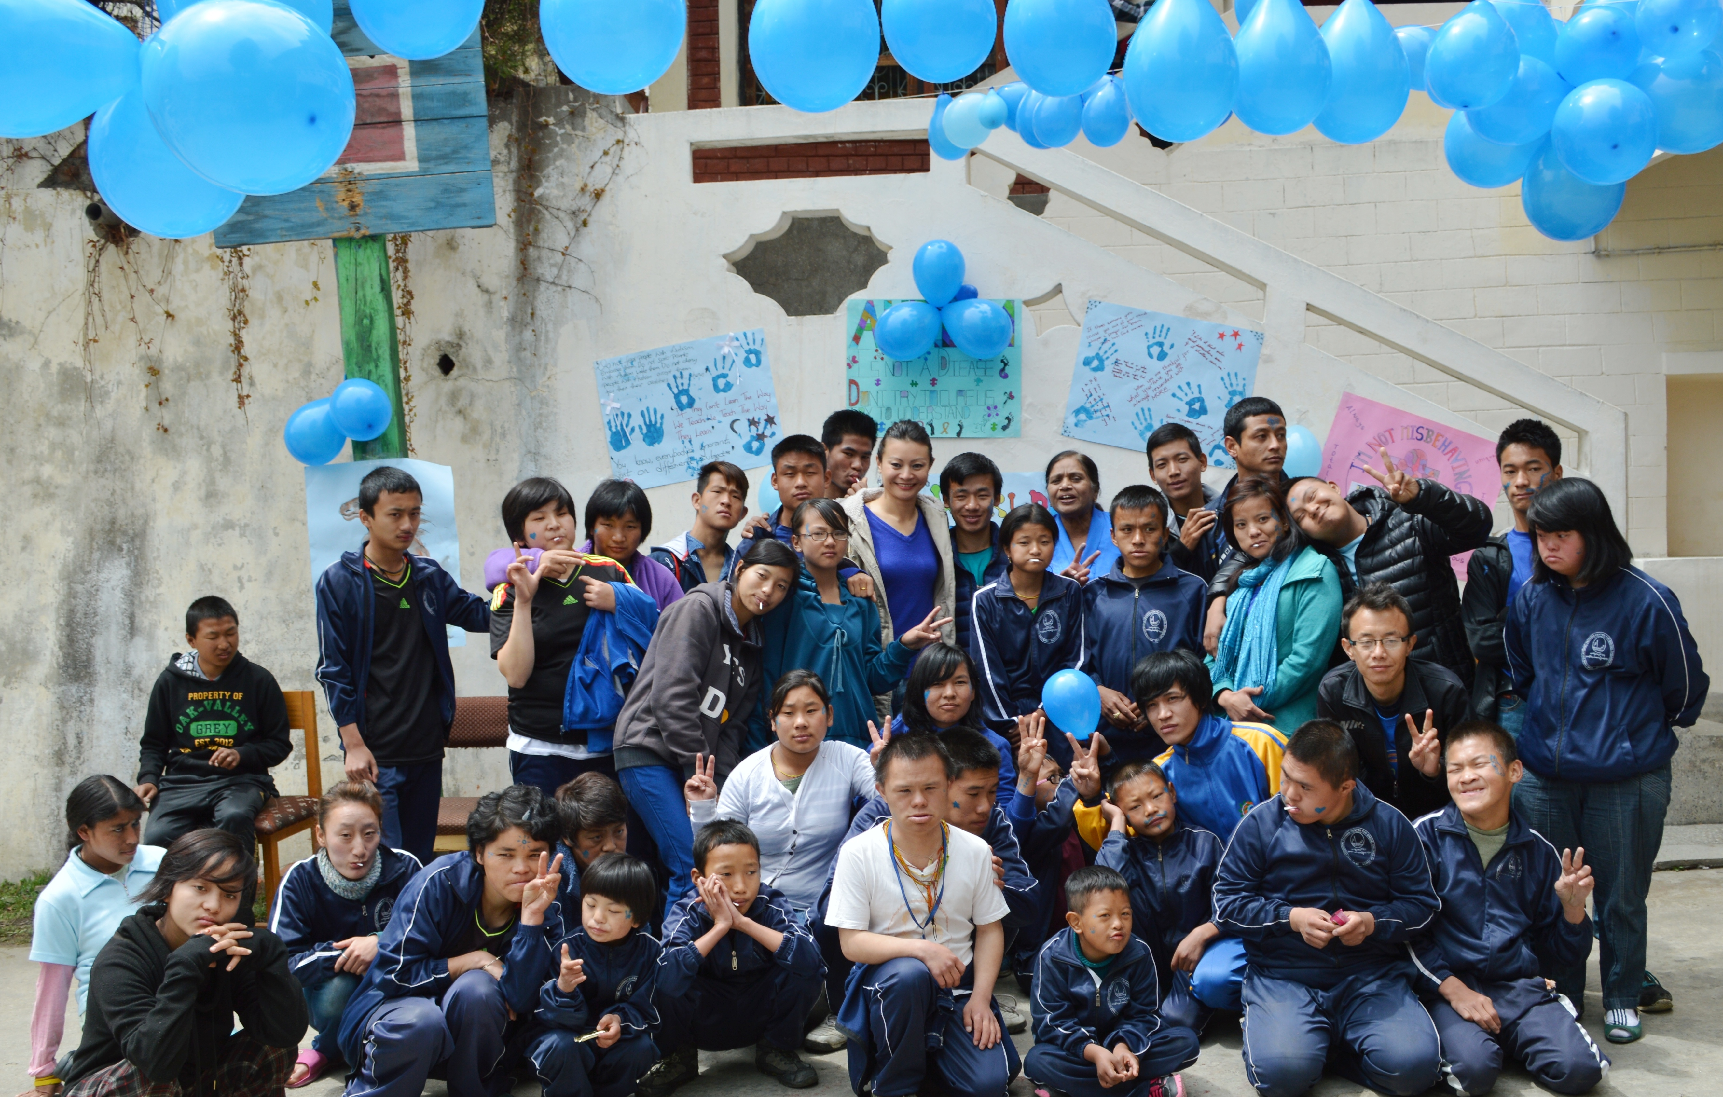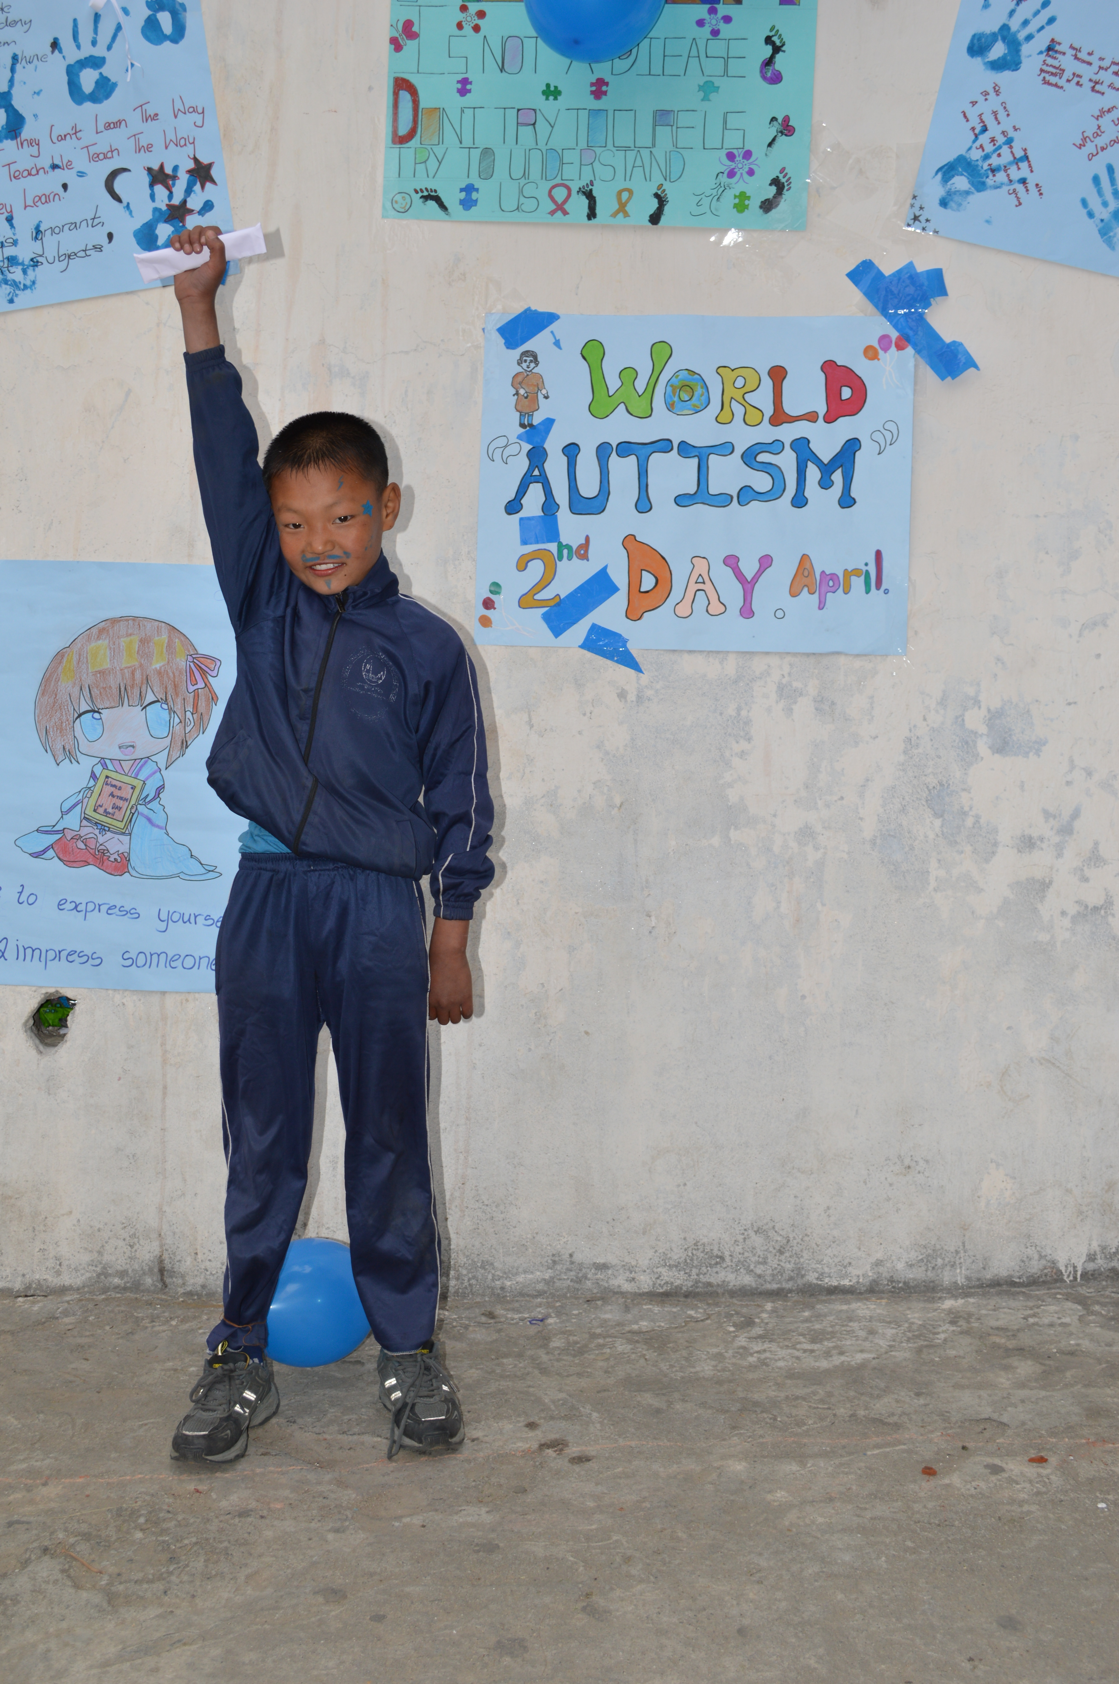
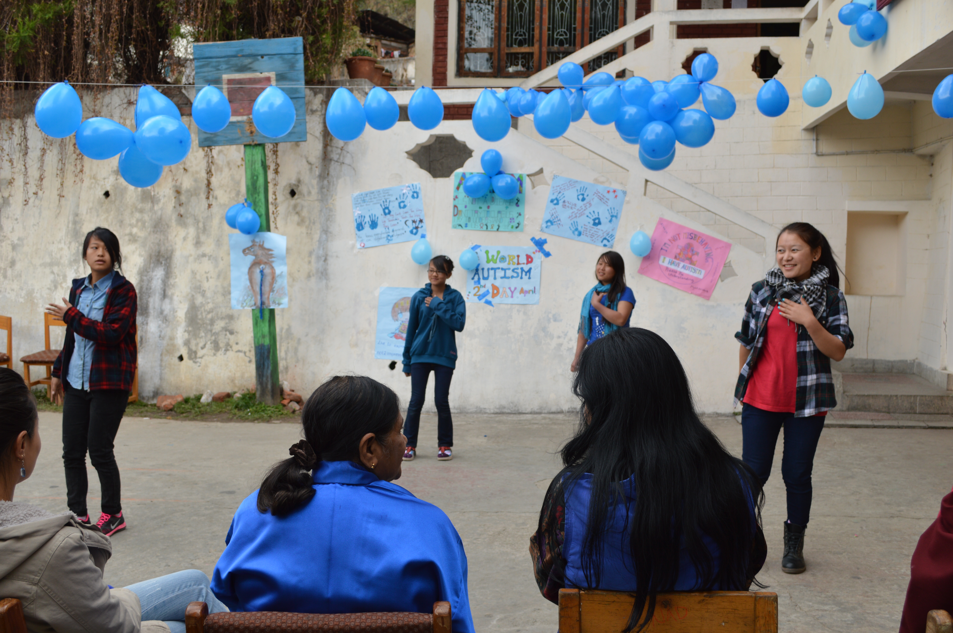

2nd May: Teachers Day celebration
On 2nd May, senior students took the initiative to organize the Teachers Day at both centres of Draktsho. The students organized tea and snacks by collecting money amongst themselves, they bought gifts for teachers, performed various cultural dances and also indulged everyone in fun games. Graduates who are working joined the occasion to pay their respect to the teachers.
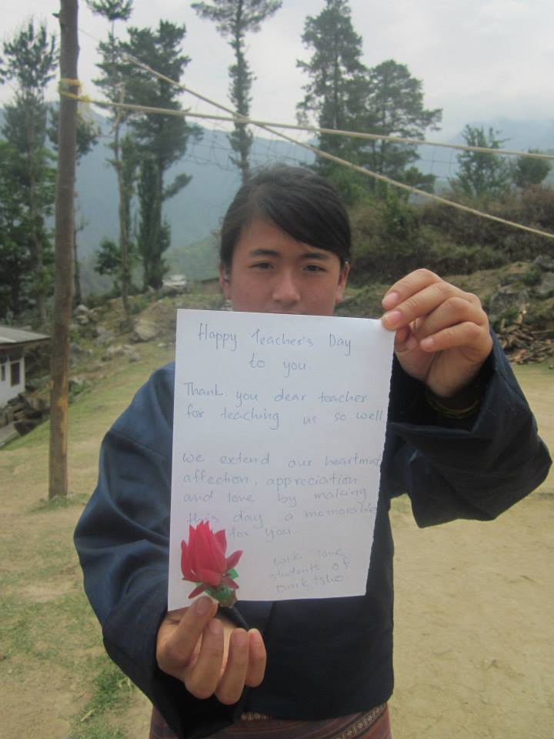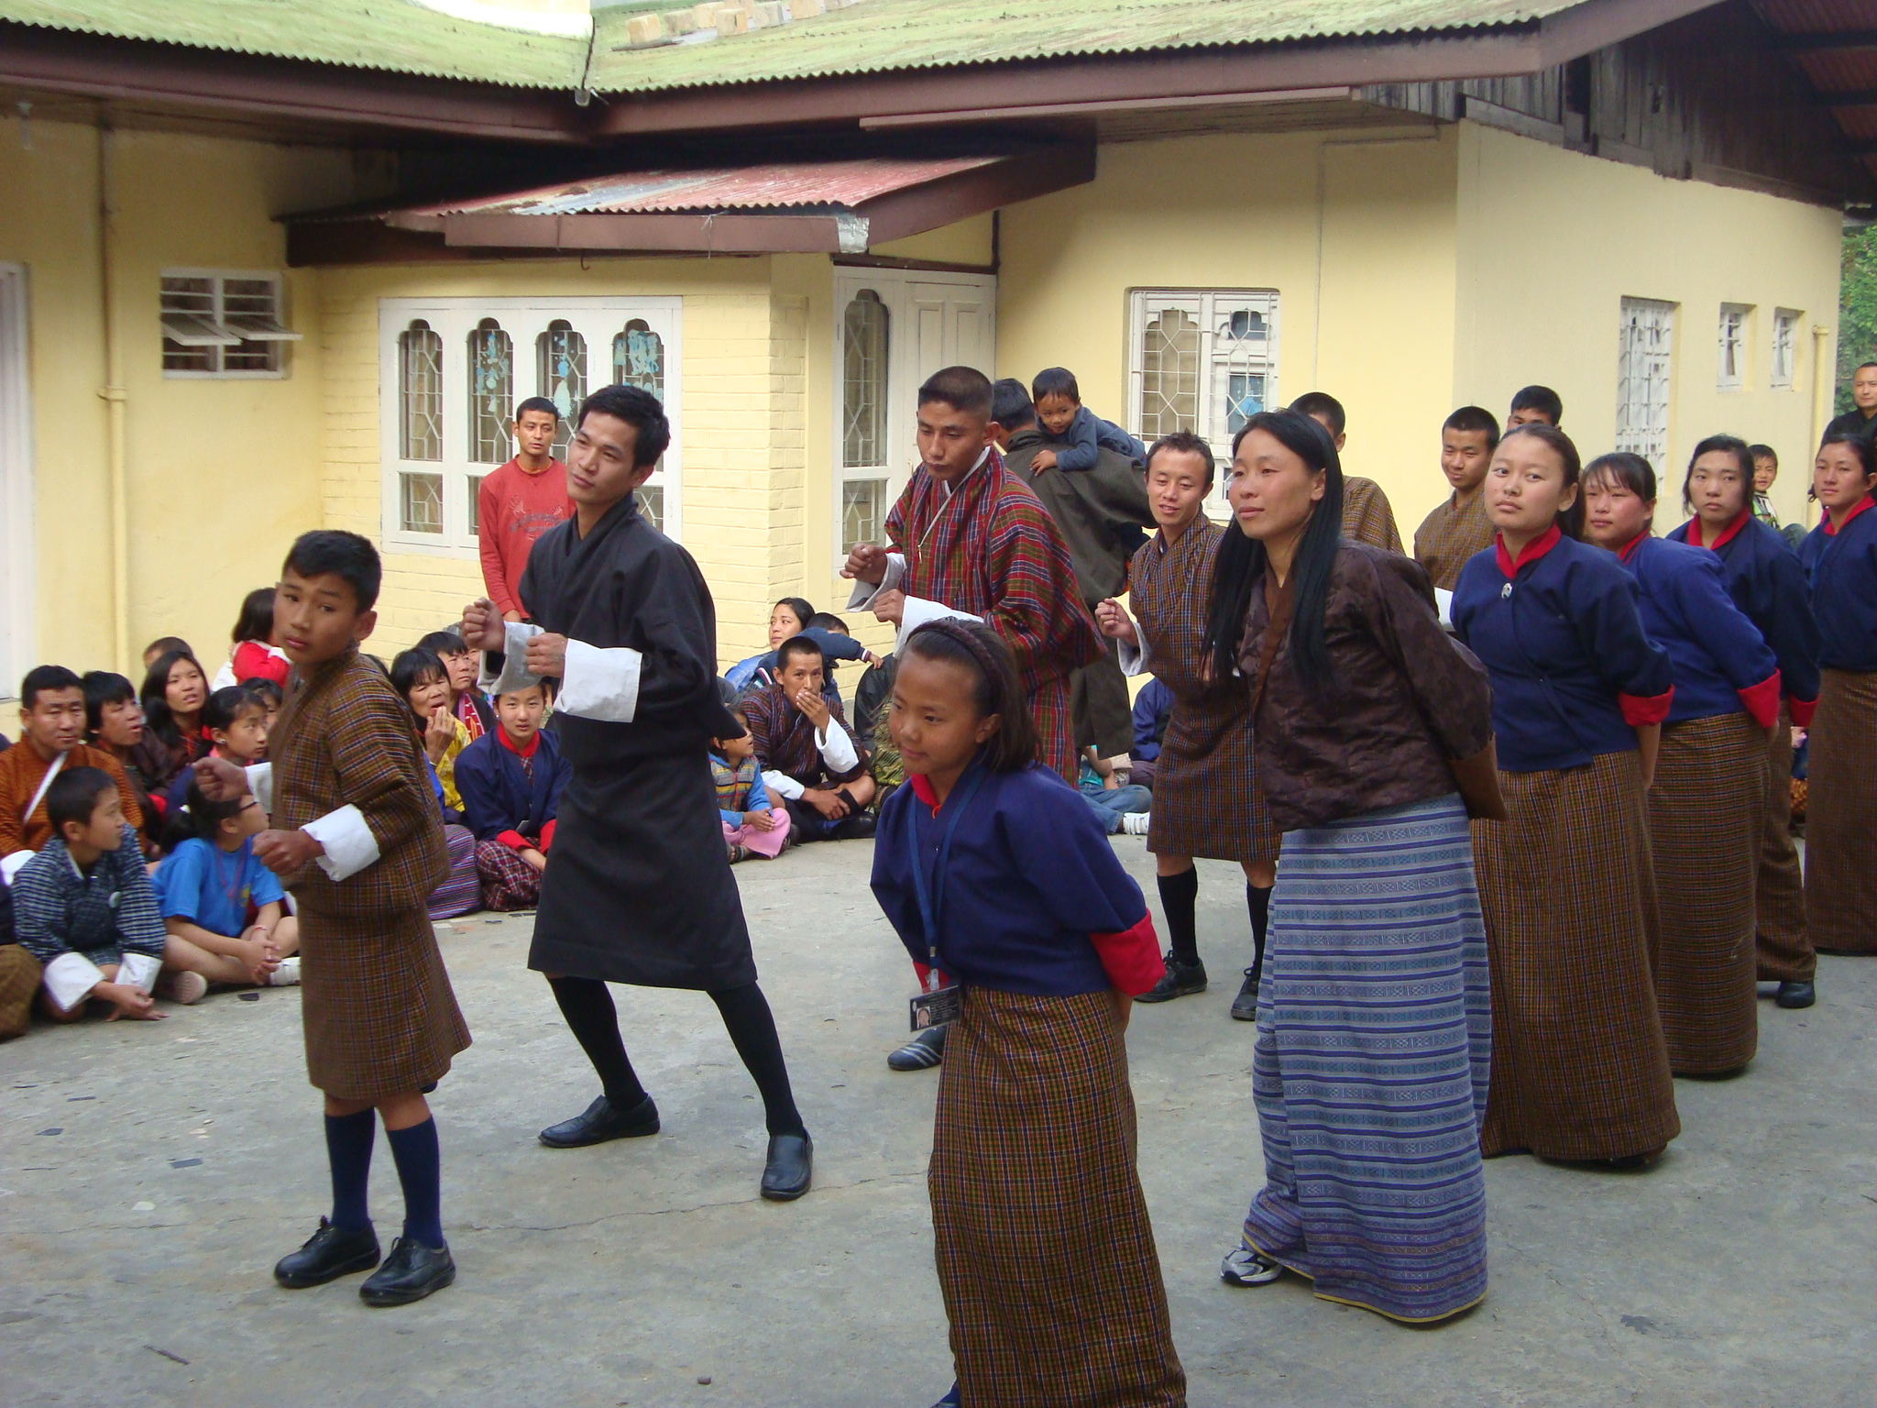

Special Olympics World Summer Games
The Special Olympics Bhutan is functioning under the umbrella of Draktsho as it has children and youth with various types of disabilities; Draksho also has the maximum number of students with intellectual disabilities undergoing training and studying. One of the main activities of Draktsho is promote the well-being of its students therefore, physical education has been an important program all along.
Draktsho participated in many international games and had won many medals. In the Special Olympic Games held in Los Angeles from 25th July -2nd August, 2015, four athletes, 2 boys and 2 girls from Draktsho were selected to participate in the Games. The athletes were selected at a national level competition where athletes from other organizations and schools competed. Our athletes Ms.Kinley Sonam Zangmo, Ms.Yshey Dema, Mr.Pelden and Mr.Phub Tshering brought back home 6 medals (3 gold, 1 silver and 2 bronze). Our athletes not only made the nation proud but also created a record in the history of Bhutan for winning 6 medals at an Olympic level.
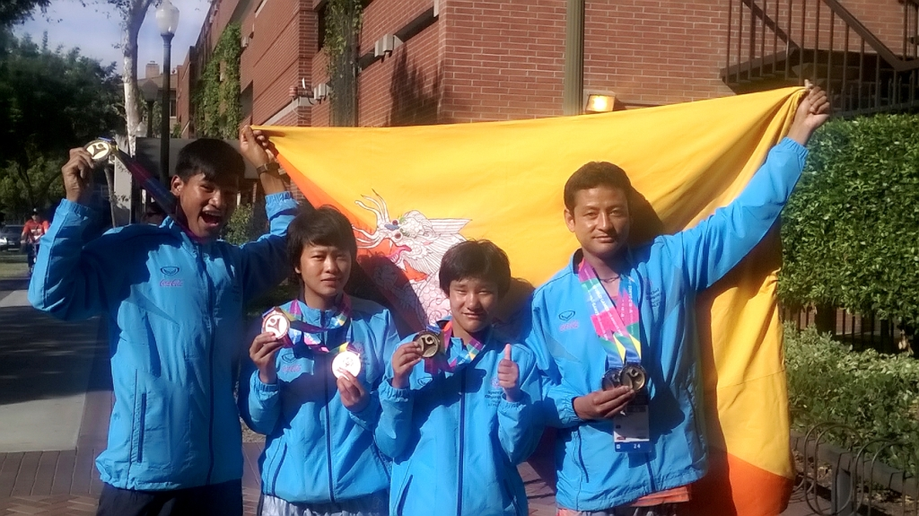
Our pride, from left:Phub Tshering ,Kinley Sonam Zangmo ,Yeshey Dema and Pelden

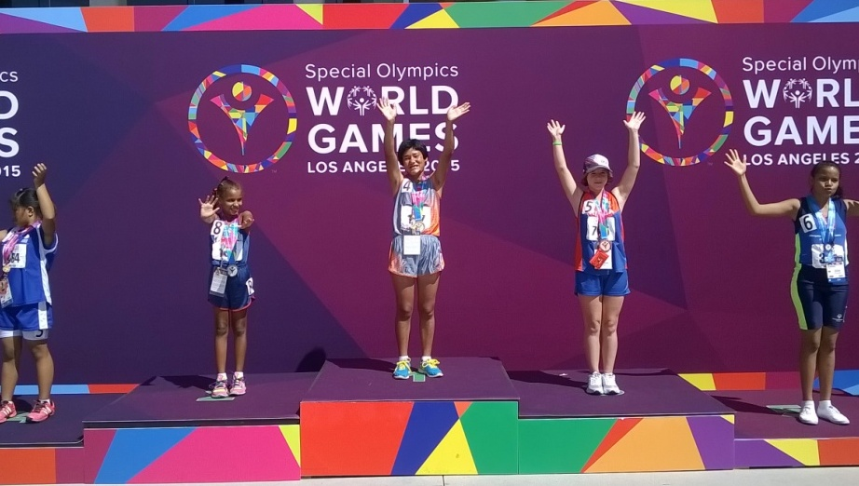
Yeshey Dema winning her first gold in 100mts race
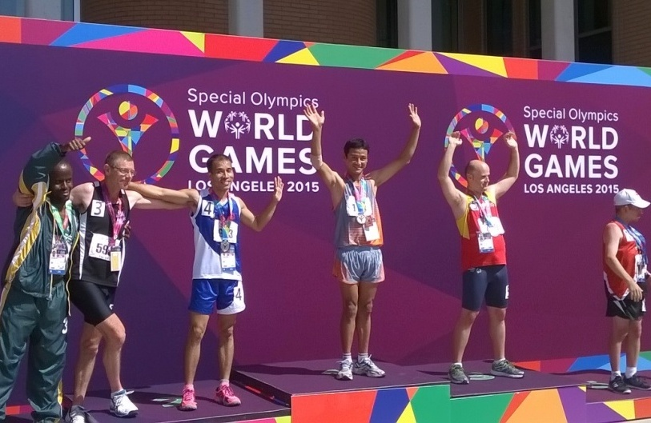
Pelden with is gold in 200 mts race
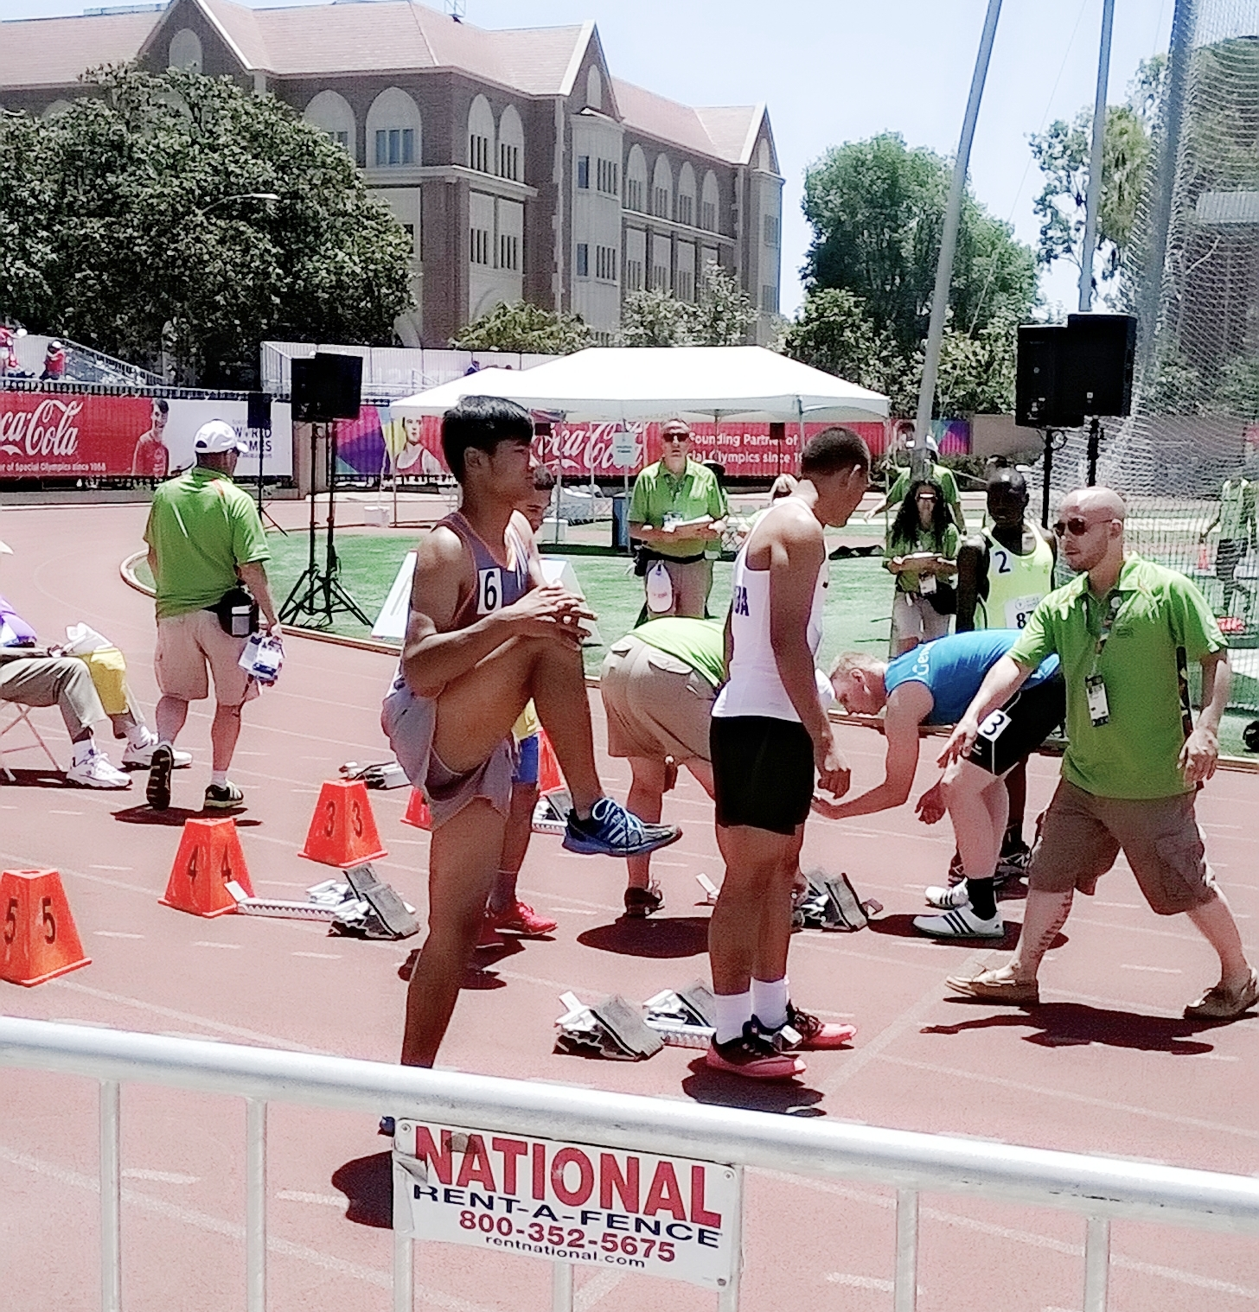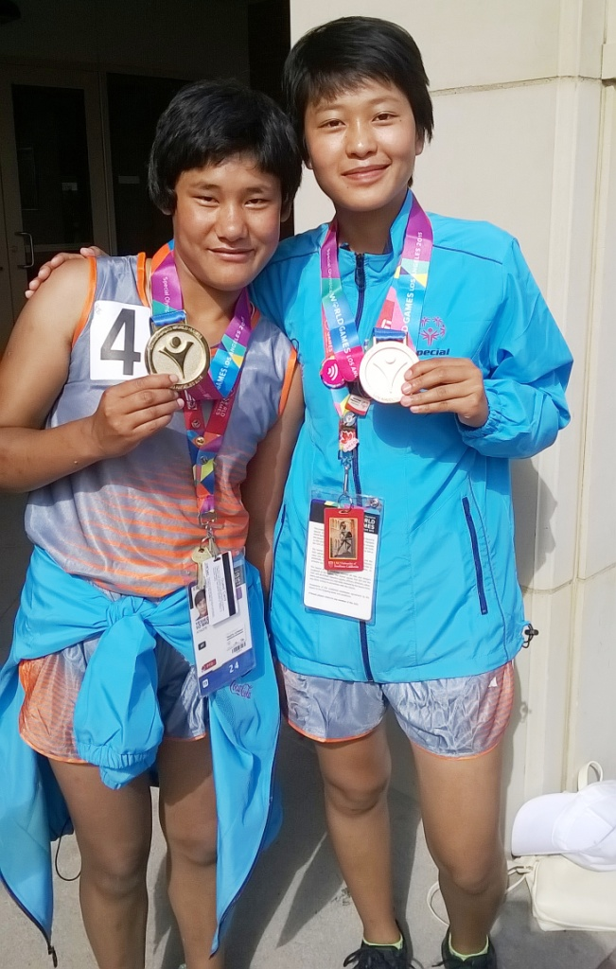
Phub Tshering Yeshey Dema & Kinley Sonam
Awareness Walk
The awareness walk is organized annually to involve the society at large in creating awareness and promoting social inclusion. On 27th September, 2015 about 150 people from all walks to life joined the awareness walk that ticked off from Kuensel Phodrang( Buddha Point ) and ended at the Bhutan Athletic Ground. The event concluded with students performing dances at the ground .

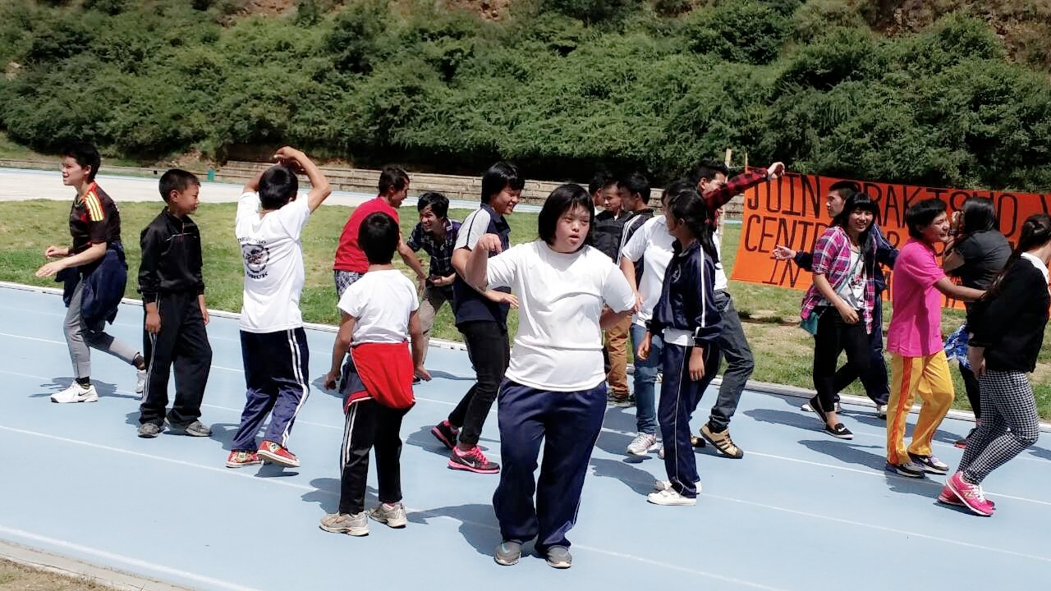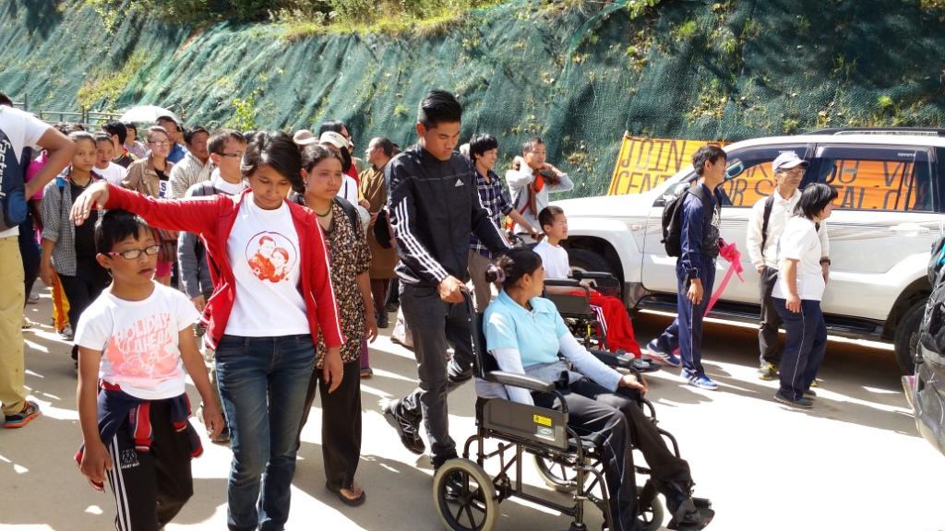

Celebrating Foundation Day
On 2nd October, Draktsho celebrated its 15th Foundation Day by going out for a picnic at Cheri, all the parents, volunteers and friends joined the students and staff. The picnic was sponsored by Ms. Lhamo Dorji, Adm. and Finance Officer, Ministry of Foreign Affairs, this was the 2nd time she supported Draktsho’s Foundation Day.

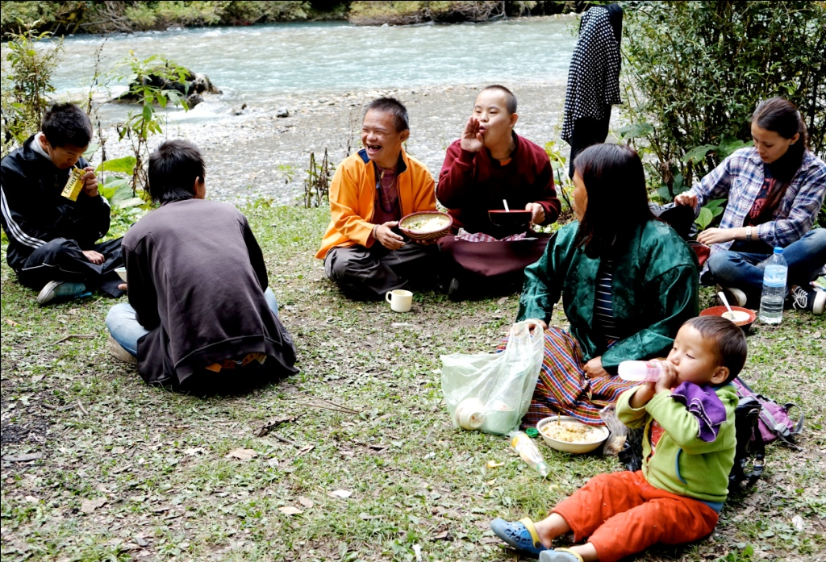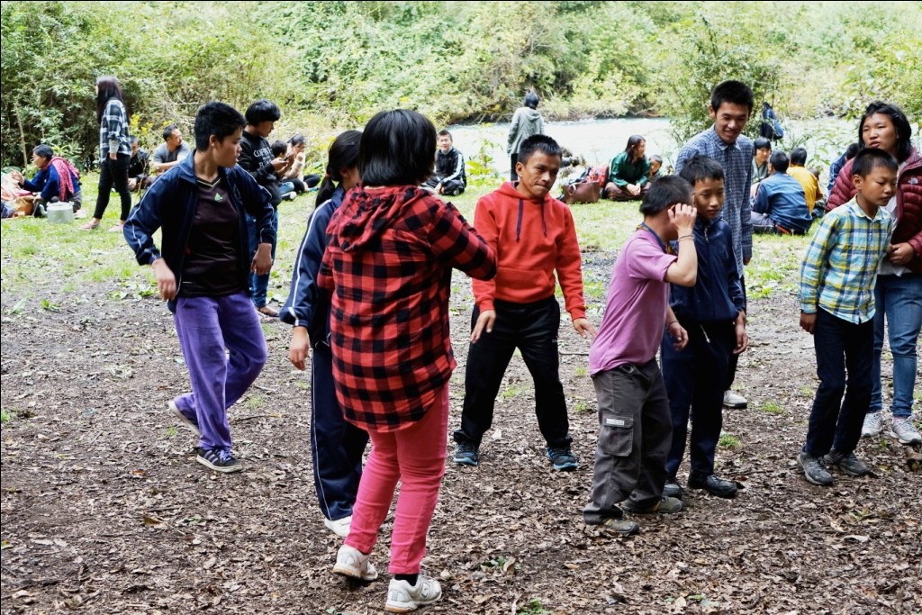

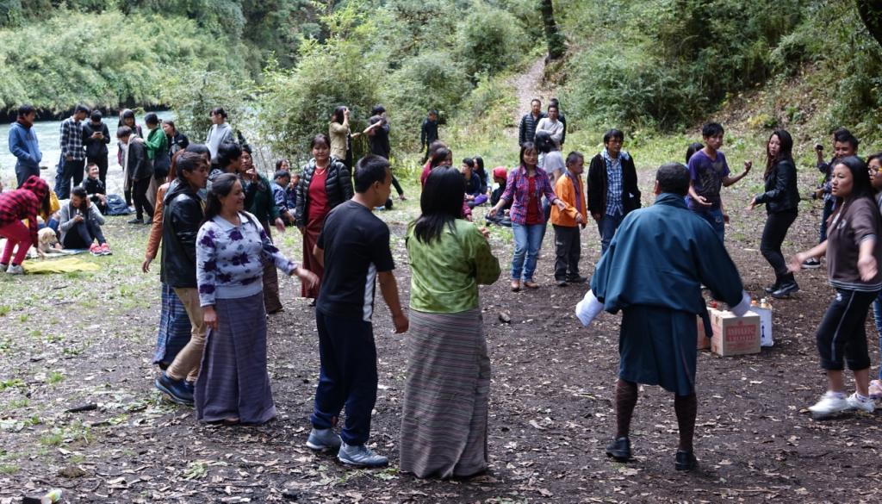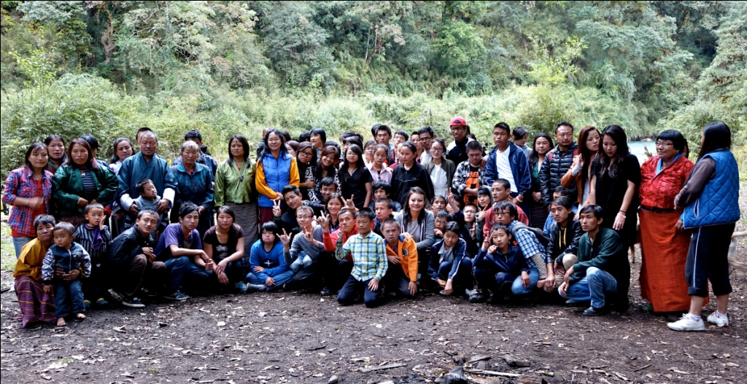

Disability Registration Project
Relevant stakeholders like Disabled People's Association of Bhutan, Tarayana Foundation, Bussi-En Group of Social Welfare Organization, Ability Bhutan Society and Draktsho collaborated and initiated the disability registration project. The stakeholders started the project in 2014 with the mission to register all persons with disabilities in all the 20 districts.
The registration was carried on with an aim to have a concrete disability statistics that specified types, severity, age and gender. The project was funded by Disabled People's Organization of Bhutan, enumerators were hired and trained for the registry work. Each organization took 3-5 and Draktsho covered the Eastern districts. The project began in 2014 and completed on 31st December, 2015.
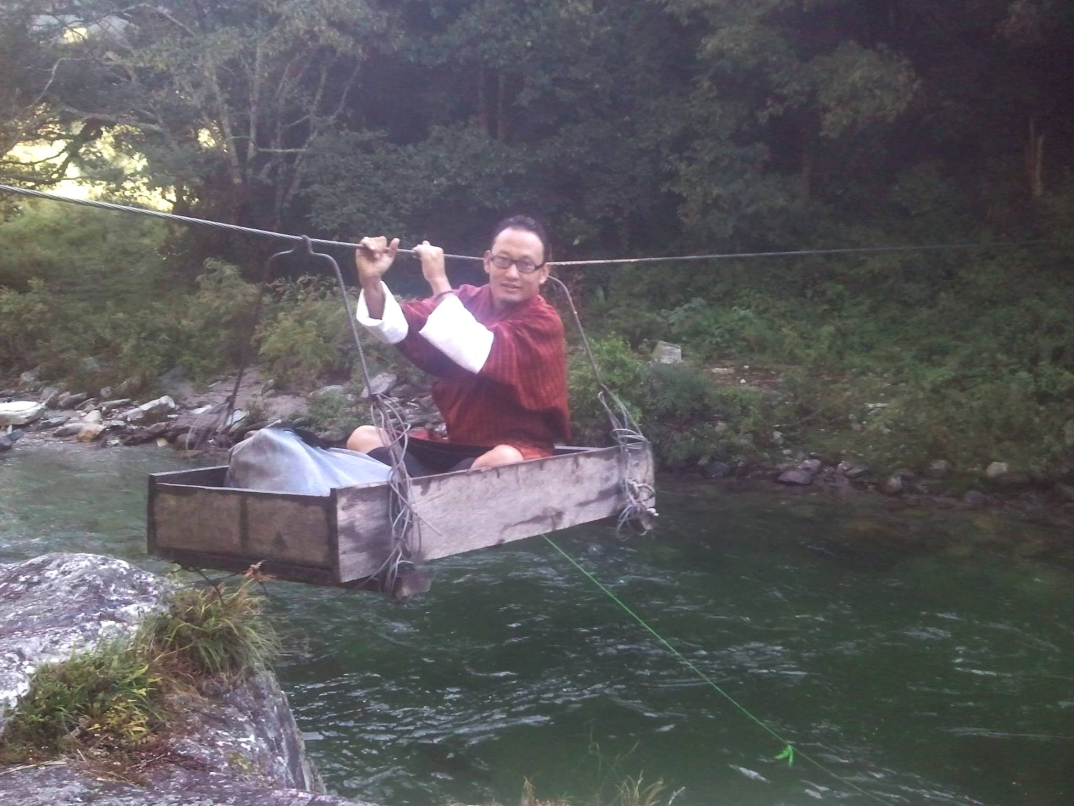
Mr.Karma Garab Dorji, Principal ,Draktsho East Centre during the registration

His Majesty the 4th Druk Gyalpo's 60th Birth Anniversary Celebration
11th November, 2015 was marked as a very special day all over the country as it was the 60th birth Anniversary of the 4th Druk Gyalpo Jigme Singye Wangchuck. Draktsho family felt humbled and honoured to have the opportunity to celebrate the Birth Anniversary of our beloved Druk Gyalpo Jigme Singye Wanchuck.
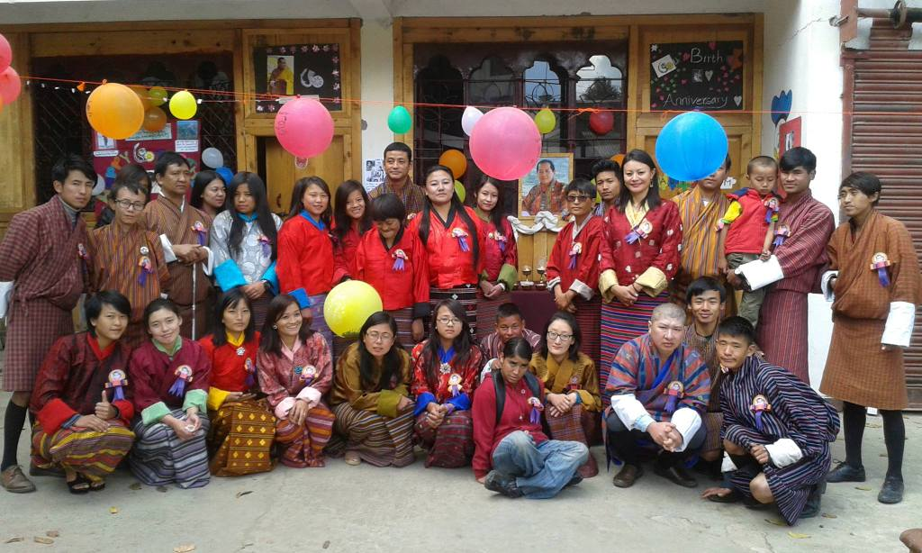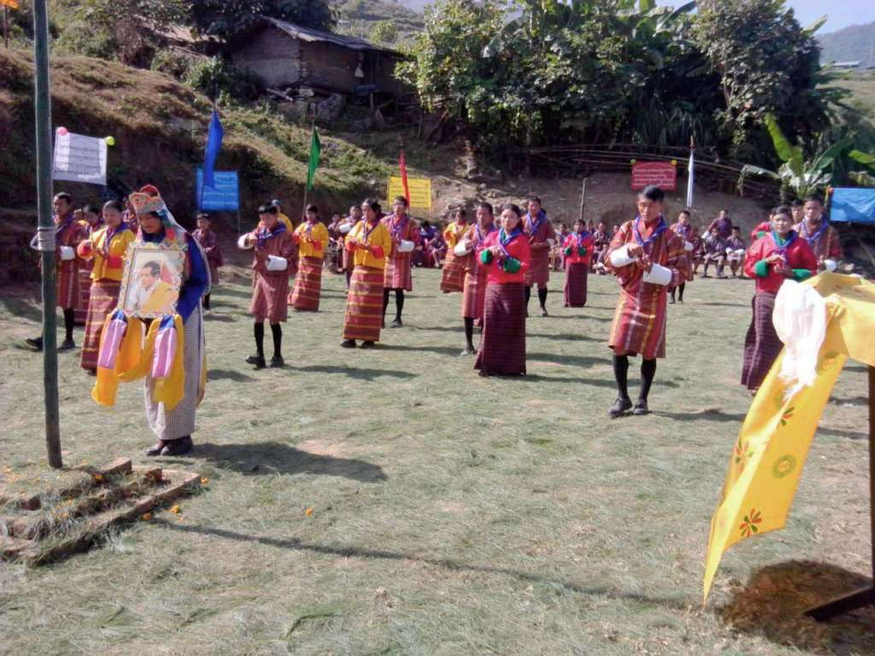
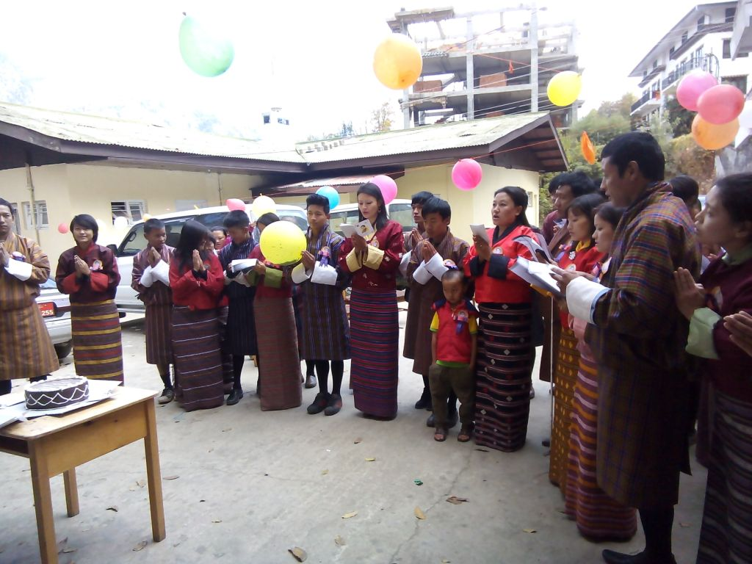
Visit of Ambassador of Embassy of Federal Republic of Germany
On 26th November, His Excellency Dr. Martin Ney the Ambassador of Embassy of Federal Republic of Germany in Delhi along with his wife visited Draktsho centre in Thimphu. In 2015 the Embassy of Germany in New Delhi provided financial support to strengthen the capacity of the centre. The fund was utilized to procure training equipments for both the centres of Draktsho. The President of Draktsho, Ashi Sonam Choden Dorji welcomed His Excellency and his wife to the short handing over ceremony and thanked them for their contribution. His Excellency visited all the class rooms and met with all the students.
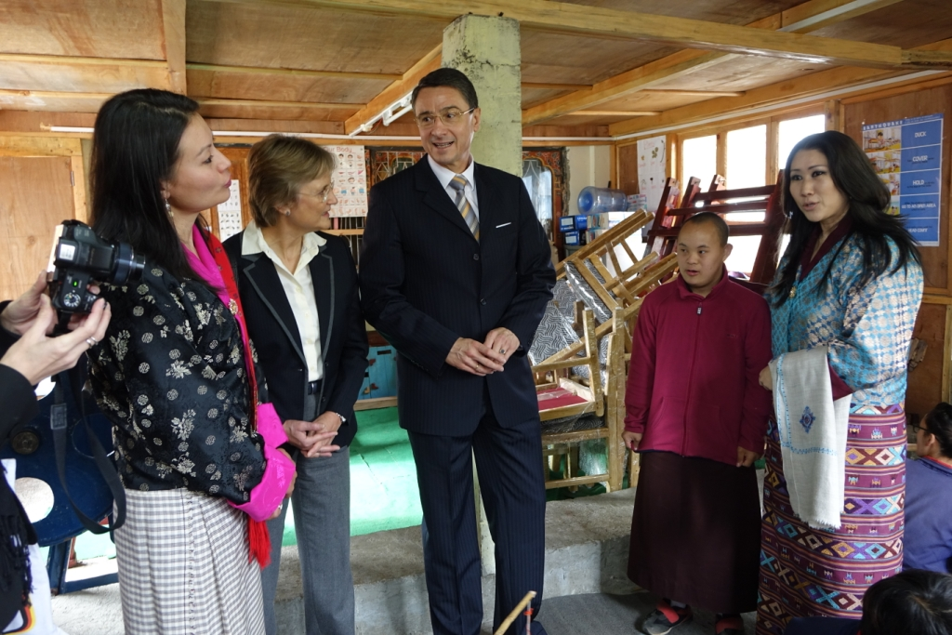
His Excellency visiting the class rooms
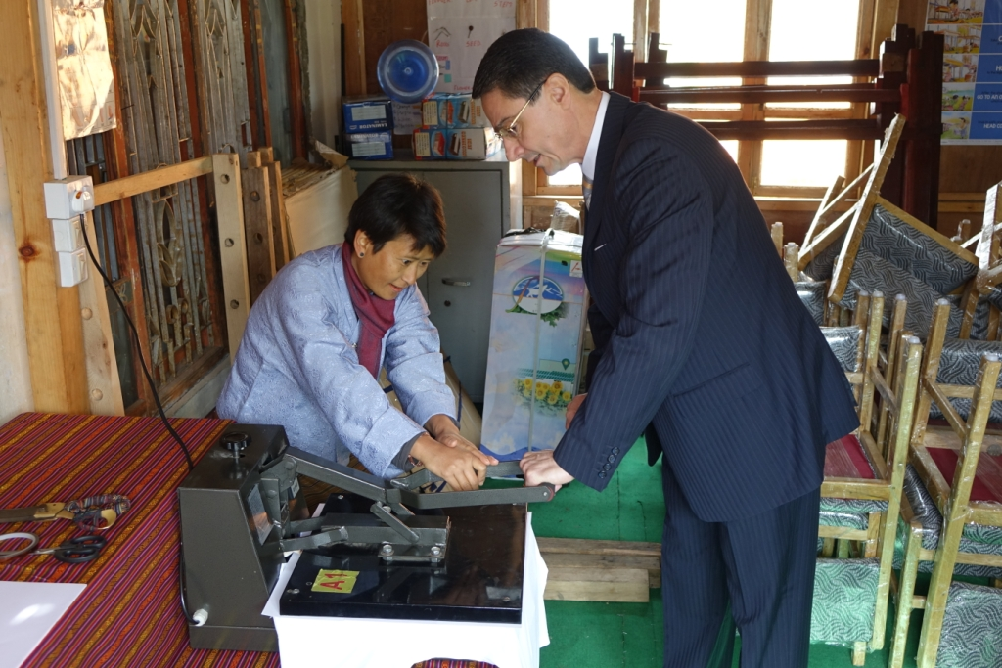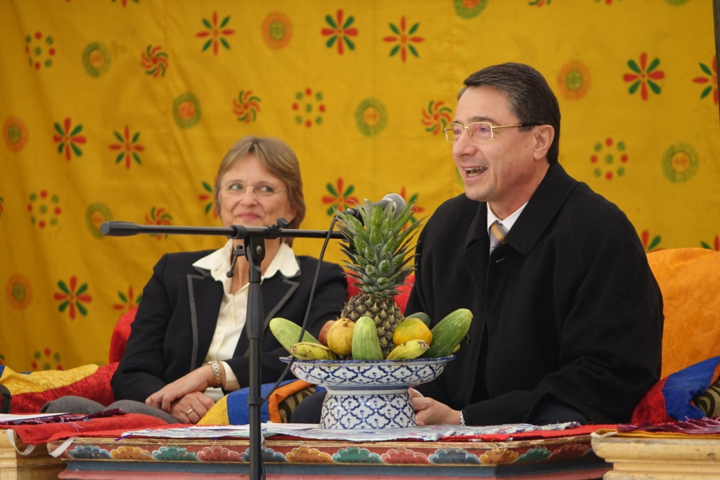

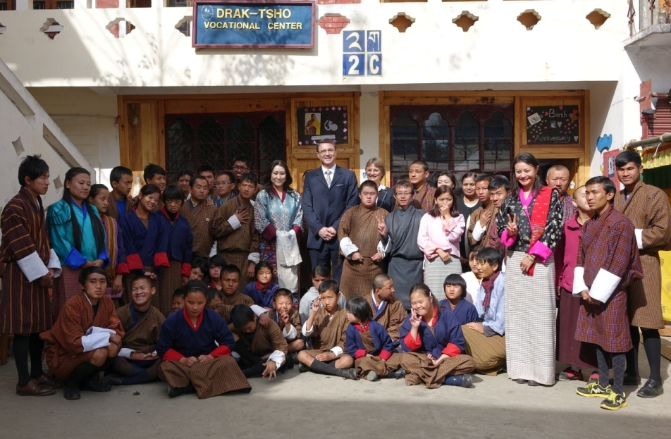

Celebration of International Day of Person's with Disabilities
The United Nations has sanctioned 3rd December as the day that celebrates progress in breaking down barrier, opening doors and realising an inclusive society for all. The theme for the International Day of Persons with Disabilities, 2015 "Inclusion matters: access and empowerment for people of all abilities" states that persons with disabilities must be given equal opportunities and empowered to be themselves ,be independent, be happy and promote inclusion .
Draktsho organized a sports competition at the Royal Bhutan Police Ground. Besides athletes from Draktsho other participants from Ability Bhutan Society, Changangkha Middles Secondary School, participated in the track and field events.
In addition to the friendly competitions by 130 athletes, Draktsho introduced "Unified Sports" through "Unified Football" for the first time. Unified Sports is a sport where athletes with and without intellectual disability, having similar age and ability come together on the same team and compete. There were 15 special athletes from Draktsho and 10 partners (regular students) who formed the first "Unified Football" team and competed.
The Mayor of Thimphu graced the occasion as the Chief Guest.

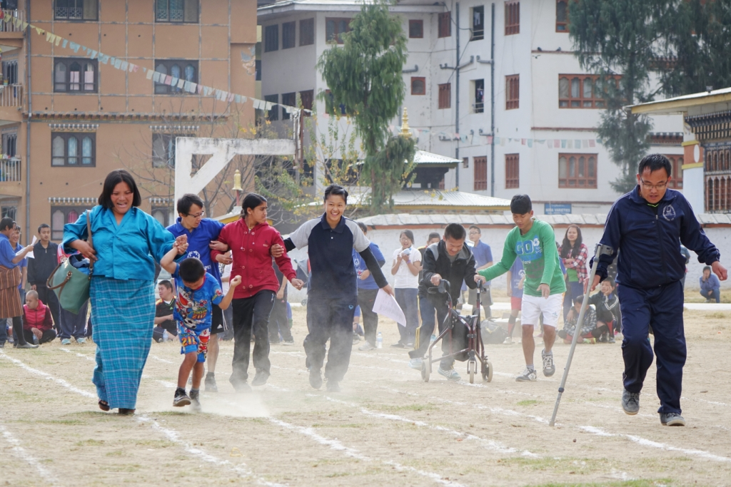

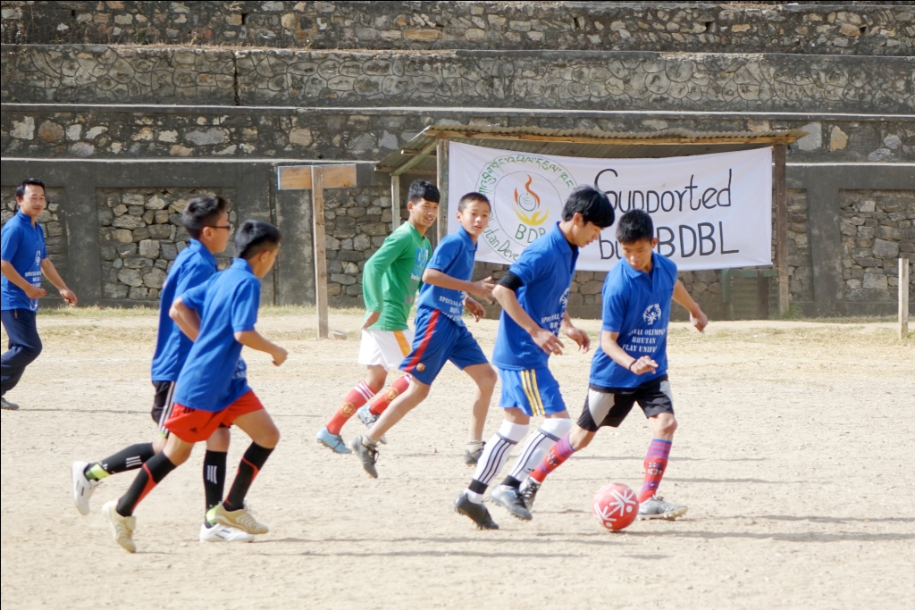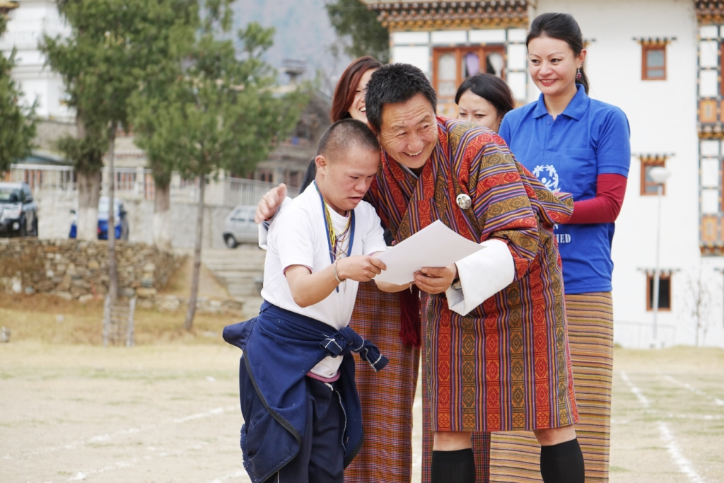

Financial Statement :

Receipt and payment of Draktsho Vocational Training Center for Special Children and Youth as on 31st December, 2015
Particulars | Receipt | Payment
RECEIPT
Opening Balance | 619,666.93
UNICEF | 669,378.00
UNDP | 854,258.00
Omega | 1,090,335.45
Local Tourist | 942,938.18
Local donation | 1,627,635.28
MoE | 540,000.00
Germany | 893,737.00
Dr. Rolf | 78,953.65
Indego | 101,631.11
Adruka | 626,500.00
Paro sales | 900,272.00
Thimphu sales | 113,316.00
Interest | 2,839.92
PAYMENT
Salary |  | 3,092,331.00
Mess |  | 880,890.60
House Rent |  | 663,000.00
Consultant fee |  | 298,101.45
Bank Charges |  | 708.00
Training Materials |  | 317,461.10
Maintenance of Building |  | 328,420.36
RICBL |  | 146,533.00
Fees and Charges |  | 47,100.00
Training Equipments |  | 372,648.00
DSA |  | 23,800.00
Electricity |  | 20,987.00
Salary advance |  | 33,500.00
Printing of Cards |  | 65,470.00
Fuel |  | 39,700.00
Production salary |  | 385,268.00
Tea items |  | 25,774.00
Repair and maintenance |  | 130,378.00
Telecom |  | 34,911.00
Stationeries |  | 33,862.00
Class room Maintenance |  | 21,530.00
RSTA & Fees |  | 11,520.00
BPC |  | 16,123.00
Training materials |  | 200,941.00
Purchase |  | 27700
Functions and celebrations |  | 22,776.00
Rimdo |  | 25,000.00
Miscellaneous Exp. |  | 250,898.00
TOTAL | 9,061,461.52 | 7,517,331.51
CLOSING BALANCE | 1,544,130.01

